ONLINE CANTEEN  SYSTEM

ADMIN & USER MODULE

***Detailed Requirement & Design Specification***

***(With Test Suite Requirement)***

**March 2023**

| **Document Information** | |
| --- | --- |
| **Document Title:** | Online Canteen System – Admin & User Module |
| **Document File Name:** | BSU_OnlineCanteenSystem_User&AdminModule |
| **Document Purpose:** | This document provides detailed requirements of the User and Admin Module for Online Canteen System. |

| **Change History** | | | | |
| --- | --- | --- | --- | --- |
| **Version No.** | **Date Changed** | **Modified By** | **Reviewed By** | **Nature of Amendment** |
| 0.1 | 23 October 2020 | Name | Name | <nature of amendment> |
|  |  |  |  |  |

**Contents**

I.                     DETAILED REQUIREMENT & DESIGN SPECIFICATION

1.       Introduction

1.1   Purpose

1.2   Overview

1.3   Document Reference

1.4   Assumptions and Constraints

1.5   Terms, Acronyms, and Abbreviations

2.       Functional Requirement

2.1   Functional/Process Flow

2.1.1 Use Case Diagram

2.1.1.1 Admin / Staff Use Case Diagram

2.1.1.2 User / Customer Use Case Diagram

 2.1.2 Process Flow Diagram

2.1.2.1 User Module Process Flow Diagram

           2.1.2.2 Admin Module Process Flow Diagram

      2.2   Screen and Field Layout

2.2.1 User Module Screen and Field Layout

2.2.1.1   Create Registration Page

2.2.1.2   Creating Billing Address Details

2.2.1.3   Create Shipping Address Details

2.2.1.4   Edit Account Details

2.2.1.5   Edit Billing Address Details

2.2.1.6   Edit Shipping Address Details

2.2.1.7   Edit Checkout Page

2.2.1.8   View About Us Page

2.2.1.9   View Dashboard – My Account Page

2.2.1.10  View Orders – My Account Page

2.2.1.11  View Addresses – My Account Page

2.2.1.12  View Account Details – My Account Page

2.2.1.13  View Home Page

  2.2.1.14  View Shop Page

2.2.1.15   View Cart Page

2.2.1.16   View Checkout Page

2.2.2 Admin Module Screen and Field Layout

2.2.2.1 Edit Website Product Page

2.2.2.2 View Website Product Page

2.2.2.3 View Order Page

2.2.2.4 View Customer Details

2.2.2.5 View Product Analytics

2.2.2.6 View Revenue Analytics

2.2.2.7 View Order Analytics

2.2.2.8 View Categories Analytics

2.2.2.9 View Stock Analytics

2.2.2.10 Update Stock

2.2.2.11 Update Delivery Status

2.3   Business Rules

3.       Appendix

II.                   TEST SUITE REQUIREMENT

**DETAILED REQUIREMENT & DESIGN SPECIFICATION**

1. **INTRODUCTION**

**1.1**   **Purpose**

The purpose of detailed requirements and design specifications is to provide clear guidance on what the software system or application is intended to do and how it should be implemented. The information is extremely important for both administrators and users because it helps them understand the system better, assess its performance, and plan and conduct testing. The detailed requirements and design specifications are necessary to ensure that software applications and systems meet the requirements of administrators and users and are delivered within the established timeframe and budget constraints. Additionally, these specifications aid in the early detection and resolution of potential problems or discrepancies during the development process, resulting in a more efficient and effective end product.

**1.2 Overview**

The system has two modules: Admin Module, and User Module. Admin Module has four functions which are to Create, View, and Edit. The Create Admin Page and Create Admin Function are used to create a new meal. The Edit Admin Page and Edit Admin Function allow the admin to modify the items including their prices, and can also enable or disable the food items depending on their availability. The View Admin Page and View Admin Function are merely for displaying the user’s details, the number of delivered and pending orders, payment transactions. In the User Module, it has Add, View, Edit, and Place Functions. The Add allows the user to add food items to their cart. The View Page is for viewing the user’s account, view the shop, and view the cart where it also has the Edit function to modify the number of items in their cart. The Place User Page and Place User Function enable the user to place and confirm their order.

**1.3 Document Reference**

| **S/N** | **Document Name** | **Reference** |
| --- | --- | --- |
|  | **WordPress** | https://batsu2023.i3techhub.com/ |

**1.4 Assumptions and Constraints**

| **S/N** | **Assumption/Constraints** |
| --- | --- |
|  | **Accuracy -** The users must be able to input accurate order details, including the correct items, quantities, and delivery or pickup instructions. Inaccurate details can lead to incorrect orders, delays, or other issues. As well, the users must be able to provide accurate payment information and ensure that the payment process will be completed successfully. Payment processing issues can lead to failed transactions or delays in order processing. |
|  | **Availability** - The users must have access to a stable internet connection to place their orders. Without internet access, the system would not be accessible. Moreover, the system must ensure that all menu items listed on the website are available for ordering. However, this may not always be the case, as certain menu items may run out or be temporarily unavailable. |
|  | **Convenient -** The system must ensure that the food is delivered or ready for pickup within the specified time frame. Any delays or problems with delivery or pickup can cause problems with the user experience. |
|  | **Menu and Price Updates** - The system must be regularly updated with new menus, prices, and specials. This requires a lot of coordination and communication between the canteen and the system provider. |
|  | **Security -** The system must be secure and protect customer payment information. Any security breaches or data leaks can lead to serious consequences for the system and its users. |
|  | **Framework -** The system must use a specific framework or none at all. It must be developed depending on the features given to boost the performance and efficiency of the webpage. |

**1.5 Terms, Acronyms, and Abbreviations**

| **Terminology/Abbreviation** | **Definition** |
| --- | --- |
| Admin Module | It is a system that consists of various features that allow an authorized person to input, create, edit, and update items. |
| User Module | It is a system which enables the users to create an account, input their information, add, edit, and delete items to their cart, place their order, and cancel it while their orders are not yet prepared. |
| String | A string refers to a succession of characters, which may be expressed as a fixed value or as a variable of some sort. |
| Text Field | A text field is a simple textual input element that allows the user to enter a limited amount of text. |
| Drop Down List | A dropdown list is a type of graphical interface element that looks like a list box and allows users to choose a single value from a list. |
| Create | It is a function in the admin/staff module the enables the user or customer to input all the products available. |
| View | It is a function in the admin module which enables the admin to see the user’s information, number of delivered and pending orders, and payment transactions. |
| Edit | It is a function in the admin module where they can make changes to the menu list. And a function in the user module to modify his or her orders. |

**2.**       **Functional Requirement**

**2.1**   **Functional/Process Flow**

**2.1.1.1 Use Case Diagram**

The diagram shows the simplest representation of a user's interaction with the online canteen system. It shows the relationship between the user and the different use cases in which the user is involved.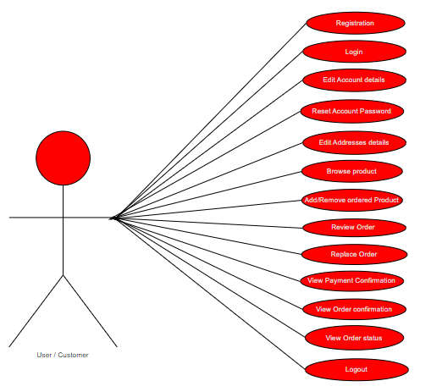

**Figure 2.1.1.1 User / Customer Use Case Diagram**

**2.1.1.2 Use Case Diagram**

The diagram shows the simplest representation of an admin's interaction with the online canteen system. It shows the relationship between the admin and the different use cases in which the admin is involved.

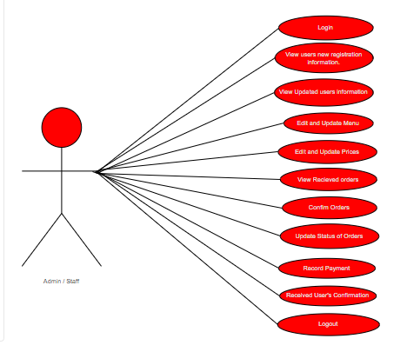

**Figure 2.1.1.2 Admin / Staff Use Case Diagram**

**2.1.2**   **Process Flow Diagram**

**2.1.2.1** User Module Process Flow Diagram

The diagram shows the overall flow of processes inside the user's system. It also illustrates the sequence of actions or services that enter or exit the process, the decisions that must be made, and the start and end of each process.

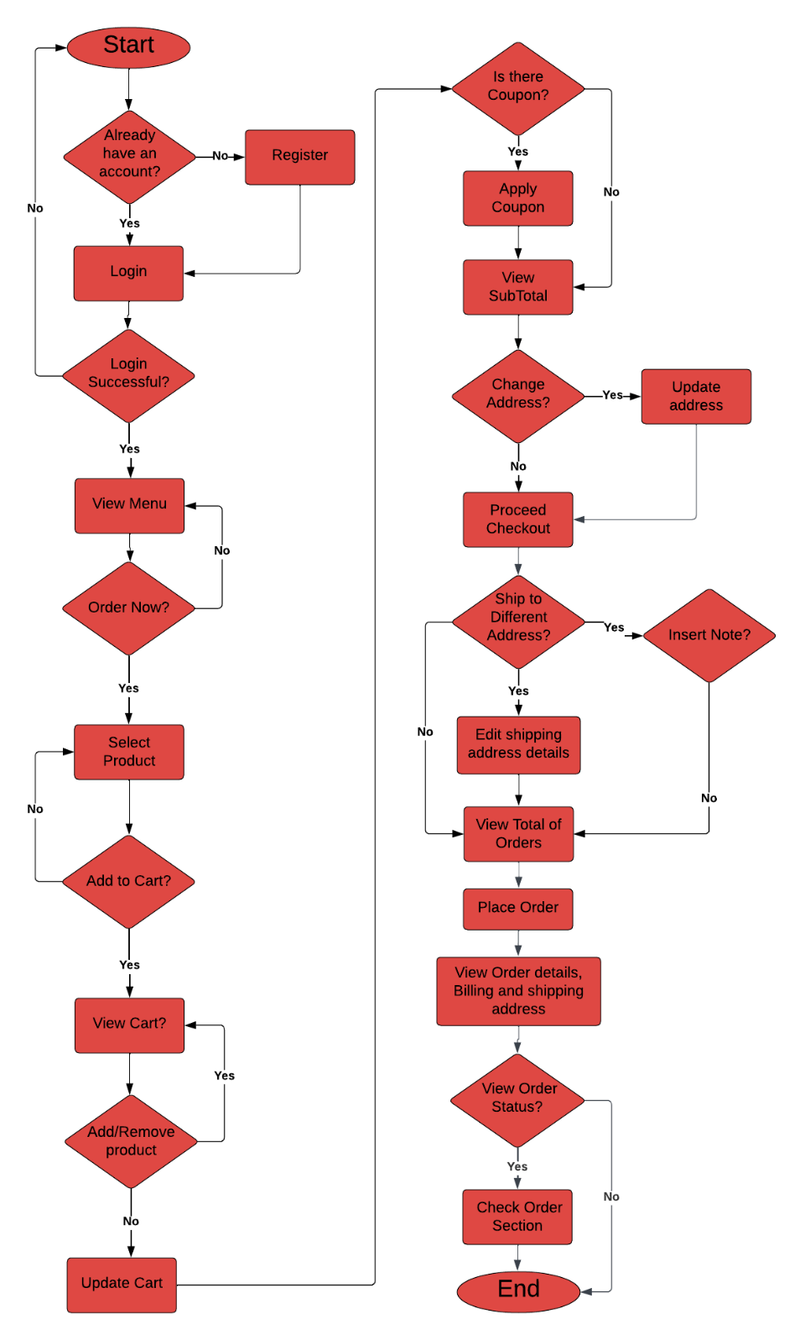

**Figure 2.1.2.1** user Module Process Flow Diagram

**2.1.2.2** Admin Module Process Flow Diagram

The diagram shows the general flow of processes within the administration system. It also illustrates the management system as well as the start and end of each process.

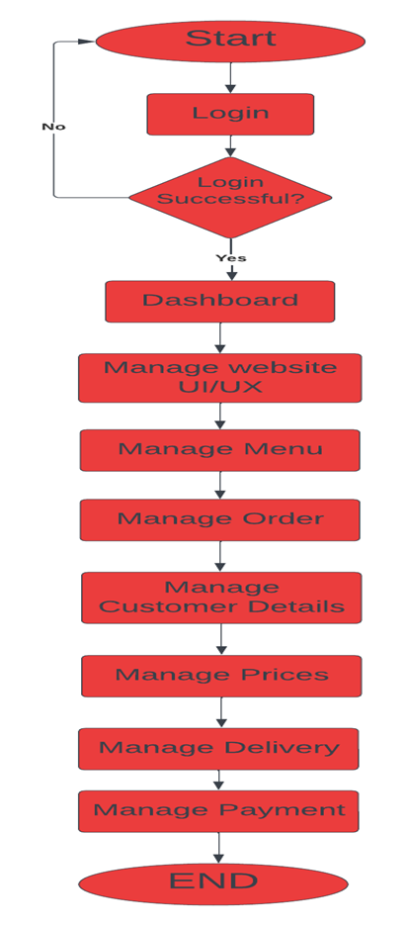

**Figure 2.1.2.2** Admin Module Process Flow Diagram

**2.2**   **Screen and Field Layout – User**

**2.2.1.1      Create Registration**

The Create Registration page is a component of the system that necessitates users to input their personal details, such as their first and last name, chosen username, email address, password, phone number and country.

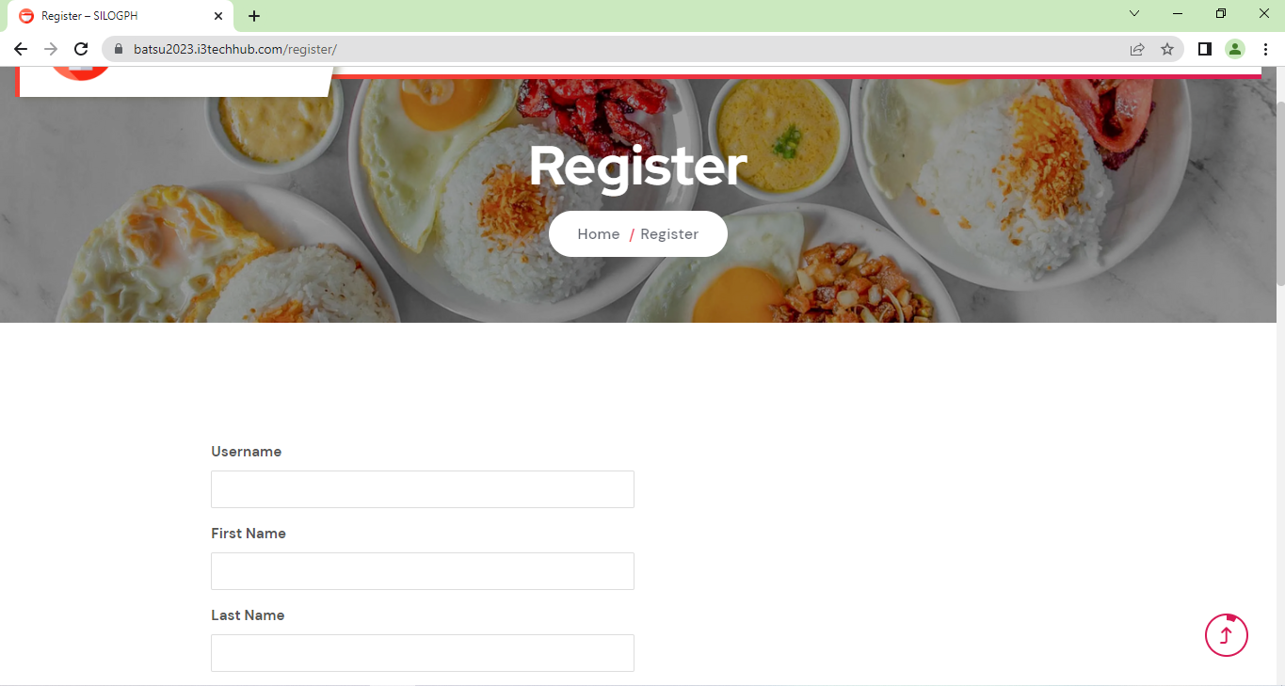

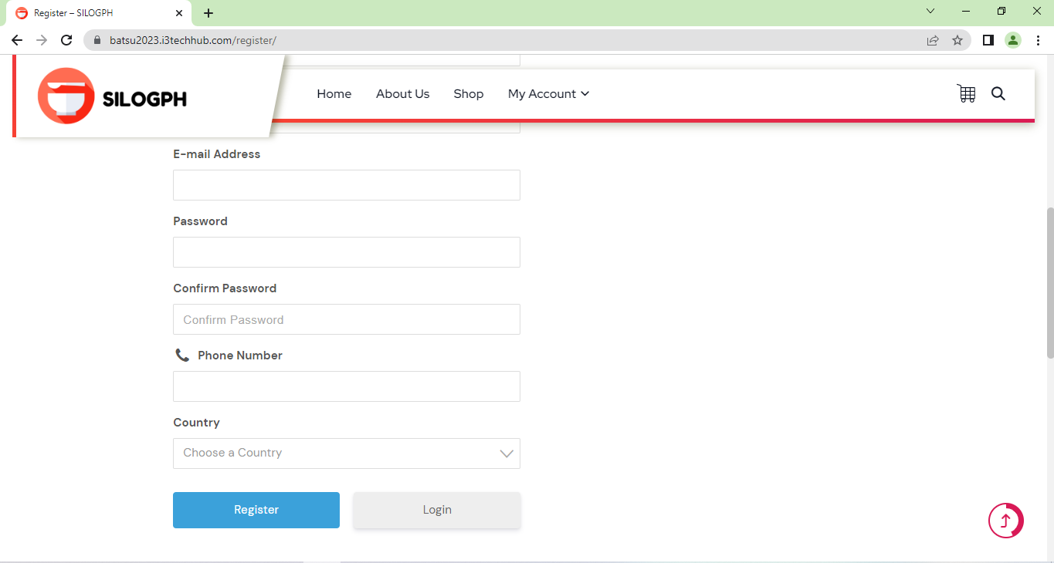

| **Field Name** | **Field Type** | **Data Type** | **Validations** | **Field Response/ Behavior** | **Mandatory** |
| --- | --- | --- | --- | --- | --- |
| User’s username | Text Field | String | ● Input should be generated into the database.  ● Input should be displayed on the registration page | ●   Displays <blank> option by default  ●   The Username is entered by the user. | Yes |
| User’s First Name | Text Field | String | ●   Input should be generated into the database.  ●   Input should be displayed on the registration page | ●   Displays <blank> option by default  ●   The First Name is entered by the user. | Yes |
| User’s Last Name | Text Field | String | ●   Input should be generated into the database.  ●   Input should be displayed on the edit and show page. | ●Displays <blank> option by default.  ●The Last Name is entered by the user. | Yes |
| User’s email address | Text Field | String | ●   Input must contain an email domain (example: gmail.com, yahoo.com, etc.,)  ● Input should be generated into the database.  ● Input should be displayed on Account Registration Page | ● Displays <blank> option by default.  ●Email Address is entered by the user | Yes |
| User’s password | Text Field | String | ●It must contain character at least one lowercase letter, one capital letter and one number  ● Input should be generated into the database. | ●Displays <blank> option by default.  ●Password is entered by the user | Yes |
| Confirm Password | Text Field | String | ●   Input should be the match to the password  ●It must contain character at least one lowercase letter, one capital letter and one number  ● Input should be generated into the database. | ●Displays <blank> option by default.  ● Confirm Password is entered by the user | Yes |
| Phone Number | Text Field | String | ●Input should be generated into the database.  ●Input should be displayed on the registration page | ● Displays <blank> option by default.  ●Contact Number is entered by the user | Yes |
| Country | Dropdown list | Text | ●Input should be generated into the database.  ●   Input should be displayed on the Registration Page | ●Displays <blank> option by default.  ●Dropdown list to select Country / region | Yes |

**2.2.1.2 Create Billing Address Details**

The Create Billing Address in addresses section of my account page is a part of the system wherein the user can input their full name, complete address and contact details.

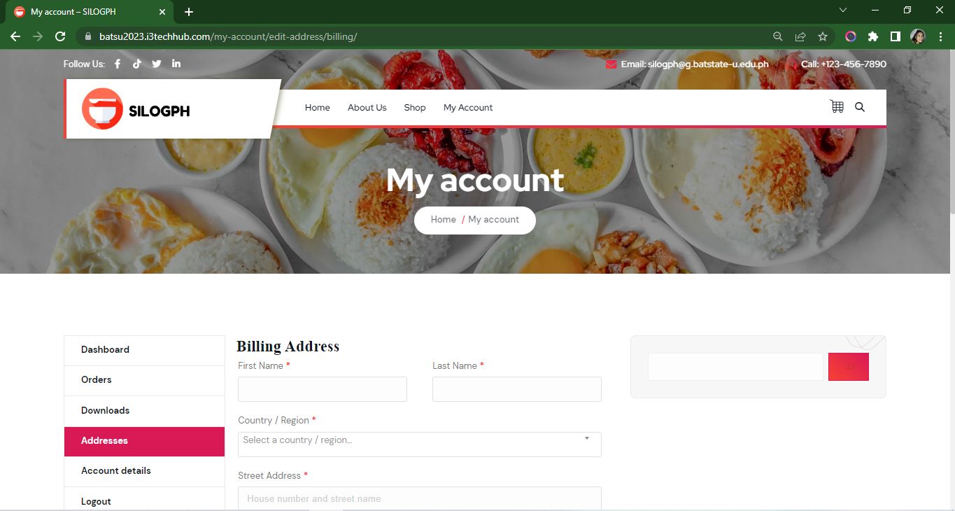

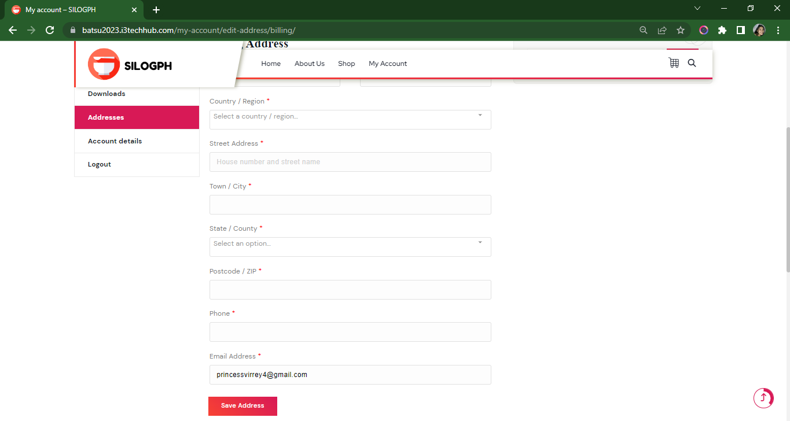

| **Field Name** | **Field Type** | **Data Type** | **Validations** | **Field Response/ Behavior** | **Mandatory** |
| --- | --- | --- | --- | --- | --- |
| User’s First Name | Text Field | String | ●   Input should be generated into the database.  ●   Input should be displayed on the Addresses section of my account page. | ●   Displays <blank> option by default  ●   The First Name is entered by the user. | Yes |
| User’s Last Name | Text Field | String | ●   Input should be generated into the database.  ●   Input should be displayed on the Addresses section of my account page. | ● Displays <blank> option by default.  ● The Last Name is entered by the user. | Yes |
| Country / Region | Dropdown list | Text | ●   Input should be generated into the database.  ●   Input should be displayed on the Addresses section of my account page. | ● Displays <blank> option by default.  ● Dropdown list to select Country / region | Yes |
| Street Address | Text Field | Text | ●   Input should be generated into the database.  ●   Input should be displayed on the Addresses section of my account page. | ● Displays <blank> option by default.  ● Street Address is entered by the user. | Yes |
| Town / City | Text Field | Text | ●   Input should be generated into the database.  ●   Input should be displayed on the Addresses section of my account page. | ●      Displays <blank> option by default.  ● Town / City is entered by the user. | Yes |
| State / County | Dropdown list | Text | ●   Input should be generated into the database.  ●   Input should be displayed on the Addresses section of my account page. | ● Displays <blank> option by default.  ● Dropdown list to select State / County | Yes |
| Postcode / Zip Code | Integer | Integer | ●   Input should be generated into the database.  ●   I Input should be displayed on the Addresses section of my account page.  ●   Input must contain exactly 4 numbers only. | ● Displays <blank> option by default.  ●Postal Code / Zip Code, this field is entered by the user.  ● Defined as a number | Yes |
| Phone Number | Text Field | String | ●   Input should be generated into the database.  ●   Input should be displayed on the Addresses section of my account page. | ● Displays <blank> option by default.  ● Contact Number is entered by the user | Yes |
| User’s email address | Text Field | String | ●   Input must contain an email domain (example: gmail.com, yahoo.com, etc,.)  ● Input should be generated into the database.  ● Input already displayed on the Addresses section of my account page upon registration. | ●E-mail Address is auto generated upon registration | Yes |

**2.2.1.3 Create Shipping Address Details**

The Create Shipping Address in addresses section of my account page is a part of the system wherein the user can input their full name and complete address. Users can also put additional notes for delivery.

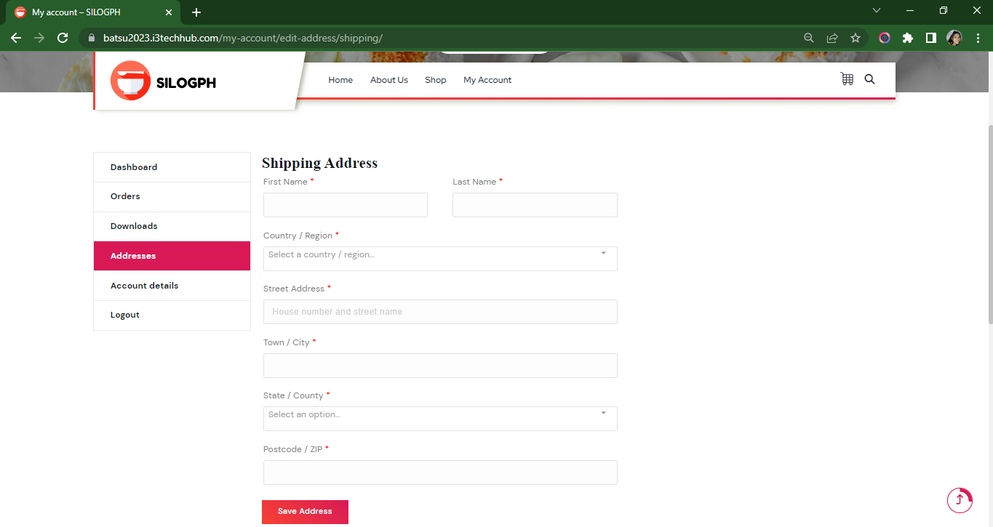

| **Field Name** | **Field Type** | **Data Type** | **Validations** | **Field Response/ Behavior** | **Mandatory** |
| --- | --- | --- | --- | --- | --- |
| User’s First Name | Text Field | String | ●   Input should be generated into the database.  ●   Input should be displayed on the Addresses section of my account page. | ●   Displays <blank> option by default  ●   The First Name is entered by the user. | Yes |
| User’s Last Name | Text Field | String | ●   Input should be generated into the database.  ●   Input should be displayed on the Addresses section of my account page. | ● Displays <blank> option by default.  ● The Last Name is entered by the user. | Yes |
| Country / Region | Dropdown list | Text | ●   Input should be generated into the database.  ●   Input should be displayed on the Addresses section of my account page. | ● Displays <blank> option by default.  ● Dropdown list to select Country / region | Yes |
| Street Address | Text Field | Text | ●   Input should be generated into the database.  ●   Input should be displayed on the Addresses section of my account page. | ● Displays <blank> option by default.  ● Street Address is entered by the user. | Yes |
| Town / City | Text Field | Text | ●   Input should be generated into the database.  ●   Input should be displayed on the Addresses section of my account page. | ●  Displays <blank> option by default.  ● Town / City is entered by the user. | Yes |
| State / County | Dropdown list | Text | ●   Input should be generated into the database.  ●   Input should be displayed on the Addresses section of my account page. | ●  Displays <blank> option by default.  ●         Dropdown list to select State / County | Yes |
| Postcode / Zip Code | Integer | Integer | ●   Input should be generated into the database.  ●   I Input should be displayed on the Addresses section of my account page.  ●   Input must contain exactly 4 numbers only. | ● Displays <blank> option by default.  ●Postal Code / Zip Code, this field is entered by the user.  ● Defined as a number | Yes |

**2.2.1.4 Edit Account Details**

The Edit Account details section is a part of the system wherein the user can replace and update their input on the My Account Page.

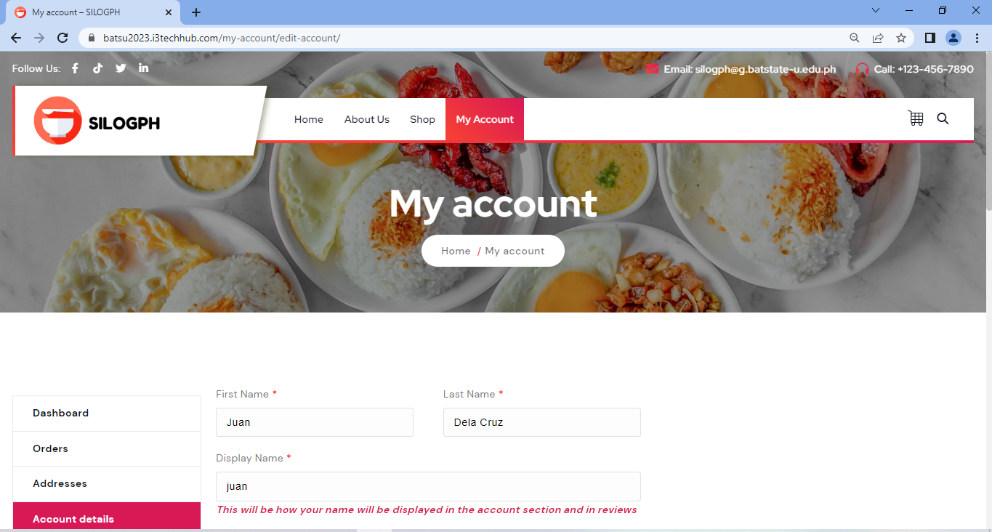

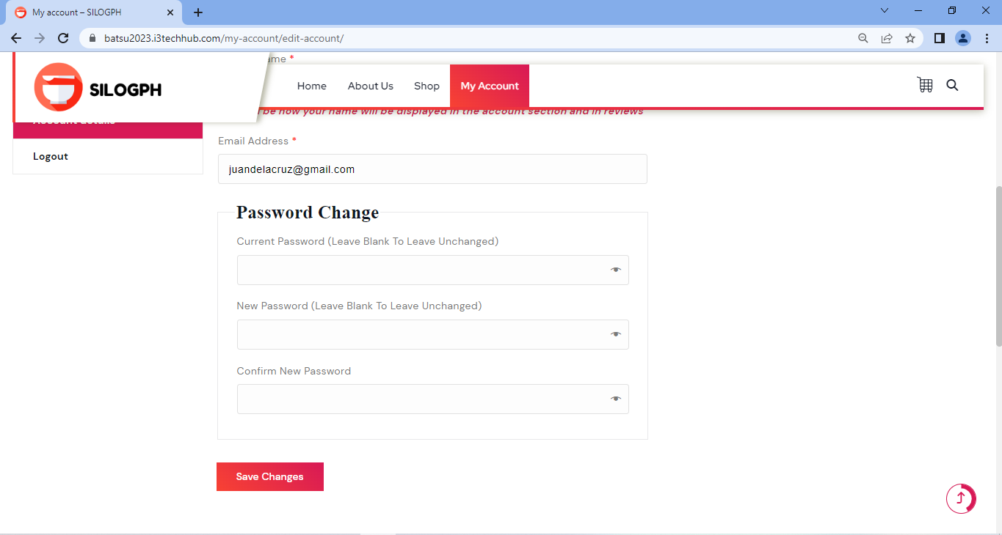

| **Field Name** | **Field Type** | **Data Type** | **Validations** | **Field Response/ Behavior** | **Mandatory** |
| --- | --- | --- | --- | --- | --- |
| First Name | Text Field | String | ● Input should be generated into the database.  ● Input should be displayed on the Account details section of my account page. | ● Displays the input created by the user on the create page.  ● Replaces the input of the user on the Account details section of my account page upon clicking the save changes button | No |
| Last Name | Text Field | String | ● Input should be generated into the database.  ● Input should be displayed on the Account details section of my account page. | ● Displays the input created by the user on the create page.  ● Replaces the input of the user on the Account details section of my account page upon clicking the save changes button | No |
| Display Name | Text Field | String | ● Input should be generated into the database.  ● Input should be displayed on the Account details section of my account page. | ● Displays the input created by the user on the create page.  ● Replaces the input of the user on the Account details section of my account page upon clicking the save changes button | No |
| Email Address | Text Field | String | ● Input should be generated into the database.  ● Input should be displayed on the Account details section of my account page.  ● Input must contain an email domain (example: gmail.com, yahoo.com, etc,.) | ● Displays the input created by the user on the create page.  ● Replaces the input of the user on the Account details section of my account page upon clicking the save changes button | No |
| Current password | Text Field | String | ●   It must contain at least * characters contain at least one lowercase letter, one capital letter and one number  ● Input should be generated into the database.  ● Input should be displayed on the Account details section of my account page. | ● Displays <blank> option by default.  ● Current Password is entered by the user  ● Replaces the input of the user on the Account details section of my account page upon clicking the save changes button | Yes |
| New password | Text Field | String | ●   It must contain at least * characters contain at least one lowercase letter, one capital letter and one number  ● Input should be generated into the database.  ● Input should be displayed on the Account details section of my account page. | ● Displays <blank> option by default.  ● Password is entered by the user  ●         Replaces the input of the user on the Account details section of my account page upon clicking the save changes button | Yes |
| Confirm Password | Text Field | String | ●   Input should be the match to the password  ● It must contain at least * characters contain at least one lowercase letter, one capital letter and one number  ● Input should be generated into the database.  ● Input should be displayed on the Account details section of my account page. | ●Displays <blank> option by default.  ● Confirm Password is entered by the user  ● Replaces the input of the user on the Account details section of my account page upon clicking the save changes button | Yes |

**2.2.1.5 Edit Billing Address**

The Edit Billing address details is a part of the system wherein the user can replace and edit their input in addresses section on the My Account Page.

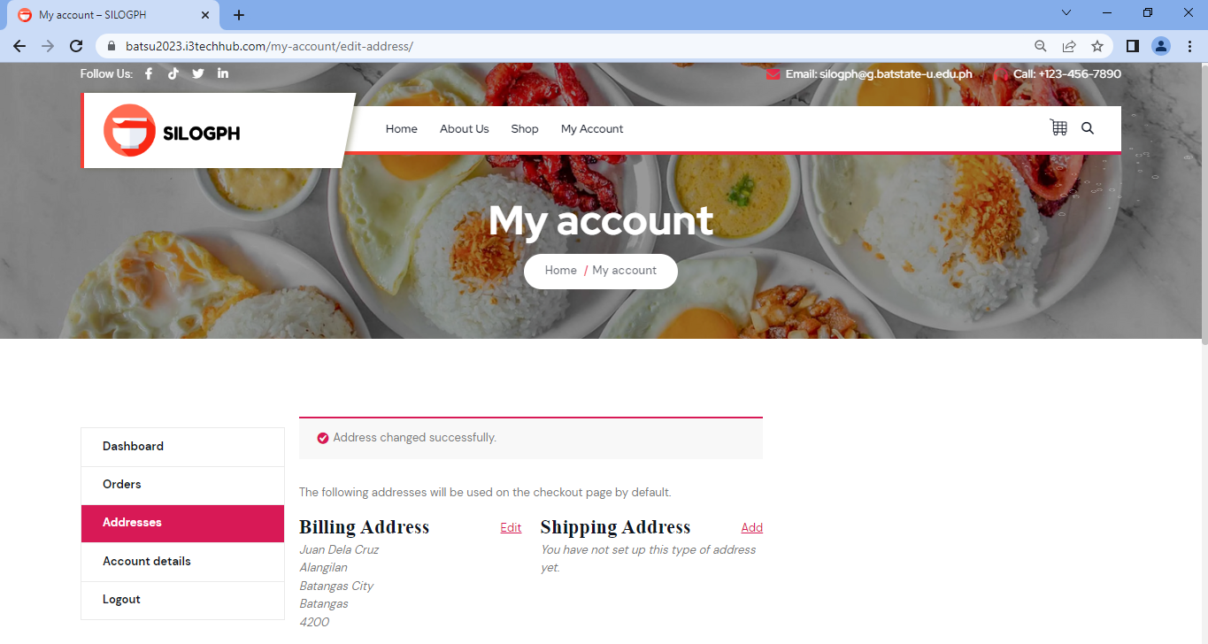

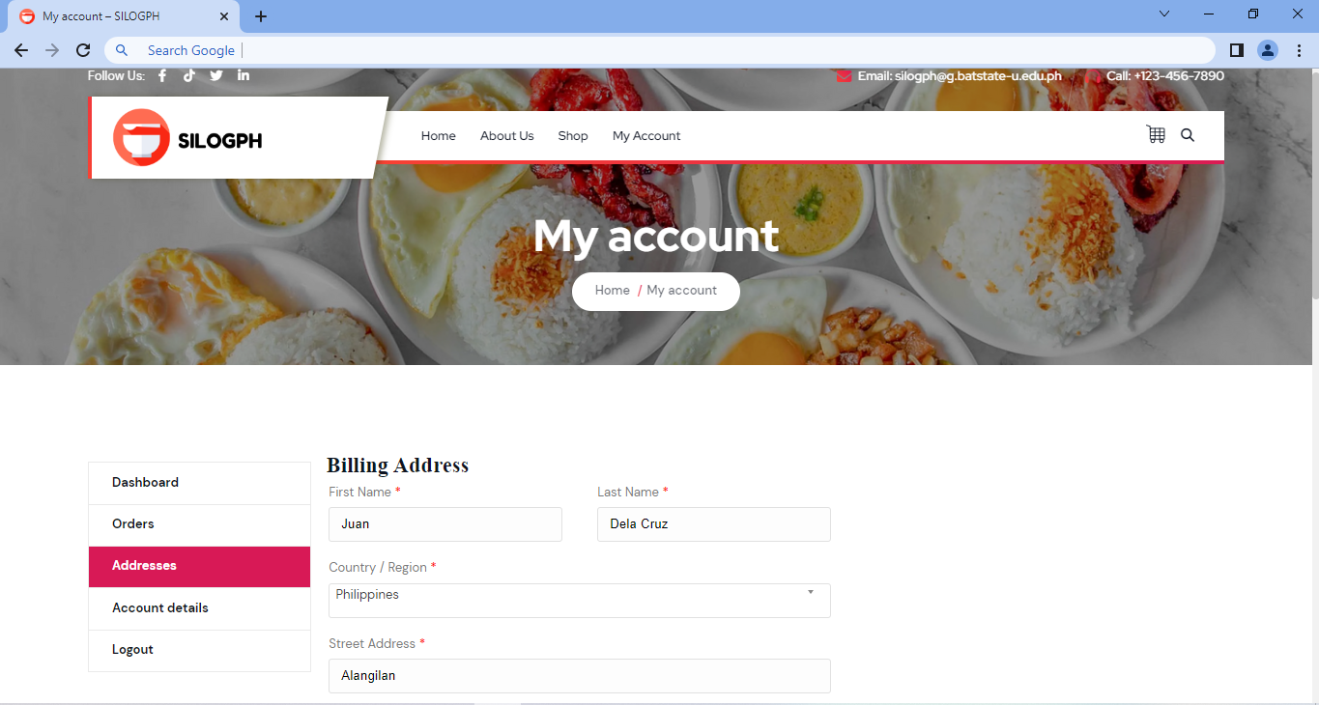

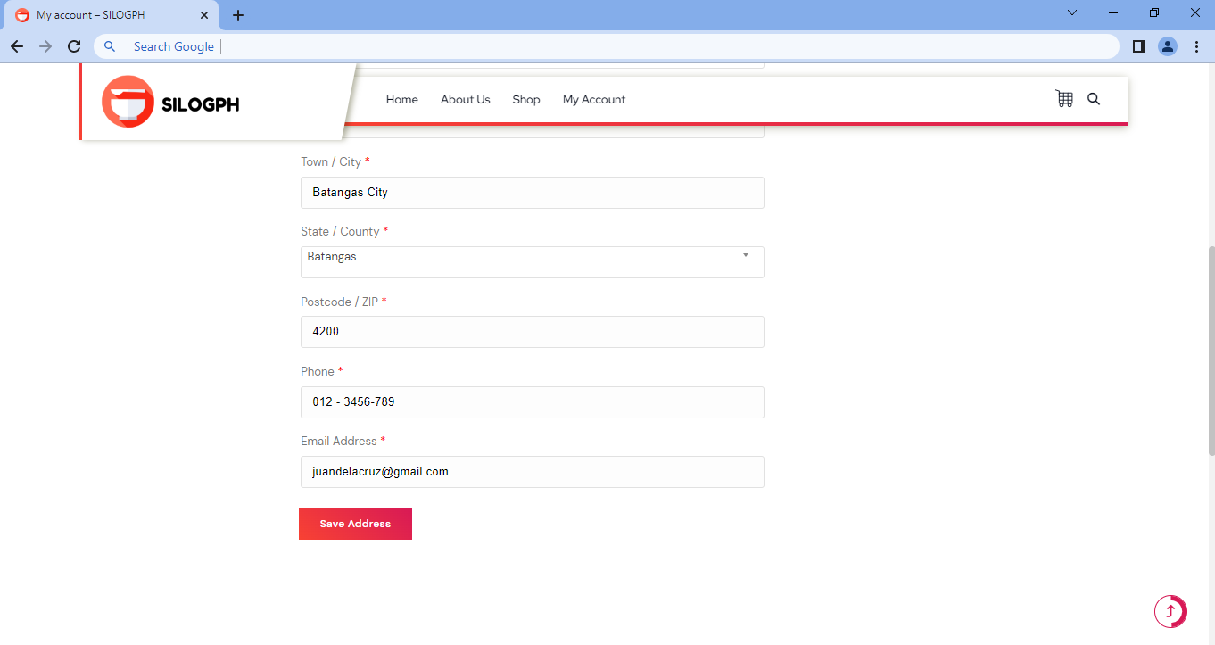

| **Field Name** | **Field Type** | **Data Type** | **Validations** | **Field Response/ Behavior** | **Mandatory** |
| --- | --- | --- | --- | --- | --- |
| User’s First Name | Text Field | String | ●   Input should be generated into the database.  ●   Input should be displayed on the Addresses section of my account page. | ● Displays the input created by the user on the Addresses section of my account page  ● Replaces the input of the user on the Addresses section of my account page upon clicking the save changes button. | No |
| User’s Last Name | Text Field | String | ●   Input should be generated into the database.  ●   Input should be displayed on the Addresses section of my account page. | ● Displays the input created by the user on the Addresses section of my account page  ● Replaces the input of the user on the Addresses section of my account page upon clicking the save | No |
| Country / Region | Dropdown list | Text | ●   Input should be generated into the database.  ●   Input should be displayed on the Addresses section of my account page. | ● Displays the input created by the user on the Addresses section of my account page ●  Replaces the input of the user on the Addresses section of my account page upon clicking the save | No |
| Street Address | Text Field | Text | ●   Input should be generated into the database.  ●   Input should be displayed on the Addresses section of my account page. | ● Displays the input created by the user on the Addresses section of my account page  ● Replaces the input of the user on the Addresses section of my account page upon clicking the save changes button. | No |
| Town / City | Text Field | Text | ●   Input should be generated into the database.  ●   Input should be displayed on the Addresses section of my account page. | ● Displays the input created by the user on the Addresses section of my account page  ● Replaces the input of the user on the Addresses section of my account page upon clicking the save changes button. | No |
| State / County | Dropdown list | Text | ●   Input should be generated into the database.  ●   Input should be displayed on the Addresses section of my account page. | ● Displays the input created by the user on the Addresses section of my account page  ● Replaces the input of the user on the Addresses section of my account page upon clicking the save changes button. | No |
| Postcode / Zip Code | Integer | Integer | ●   Input should be generated into the database.  ●   I Input should be displayed on the Addresses section of my account page.  ●   Input must contain exactly 4 numbers only. | ● Displays the input created by the user on the Addresses section of my account page  ● Replaces the input of the user on the Addresses section of my account page upon clicking the save changes button.  ●Defined as a number  ●Input must contain exactly 4 numbers only. | No |
| Phone Number | Text Field | String | ●   Input should be generated into the database.  ●   Input should be displayed on the Addresses section of my account page. | ● Displays the input created by the user on the Addresses section of my account page  ● Replaces the input of the user on the Addresses section of my account page upon clicking the save changes button. | No |
| User’s email address | Text Field | String | ●   Input must contain an email domain (example: gmail.com, yahoo.com, etc,)  ● Input should be generated into the database.  ● Input already displayed on the Addresses section of my account page upon registration. | ● Displays the input created by the user on the Addresses section of my account page  ● Replaces the input of the user on the Addresses section of my account page upon clicking the save changes button. | No |

**2.2.1.6 Edit Shipping Address**

The Edit Shipping address details is a part of the system wherein the user can replace and edit their input in addresses section on the My Account Page.

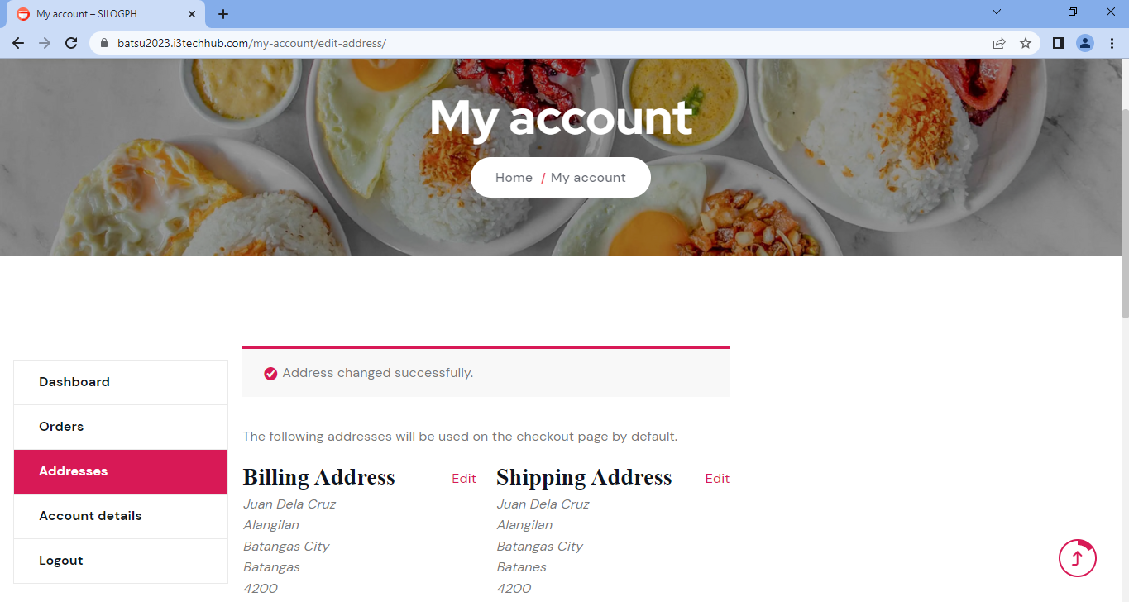

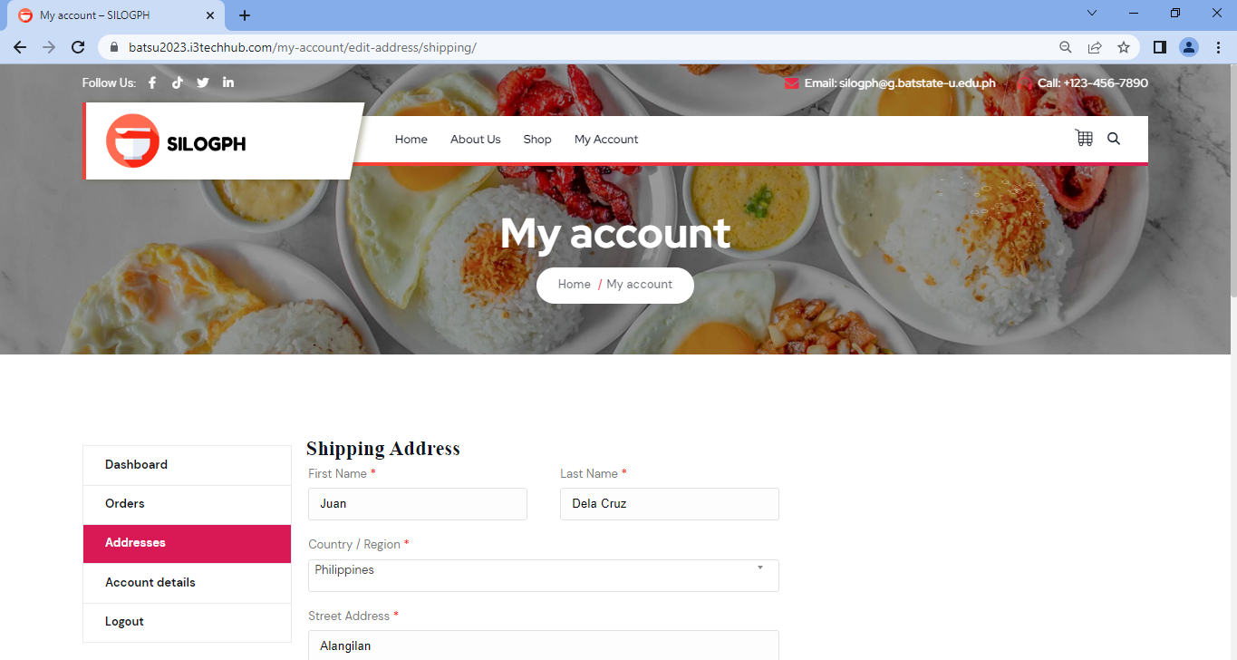

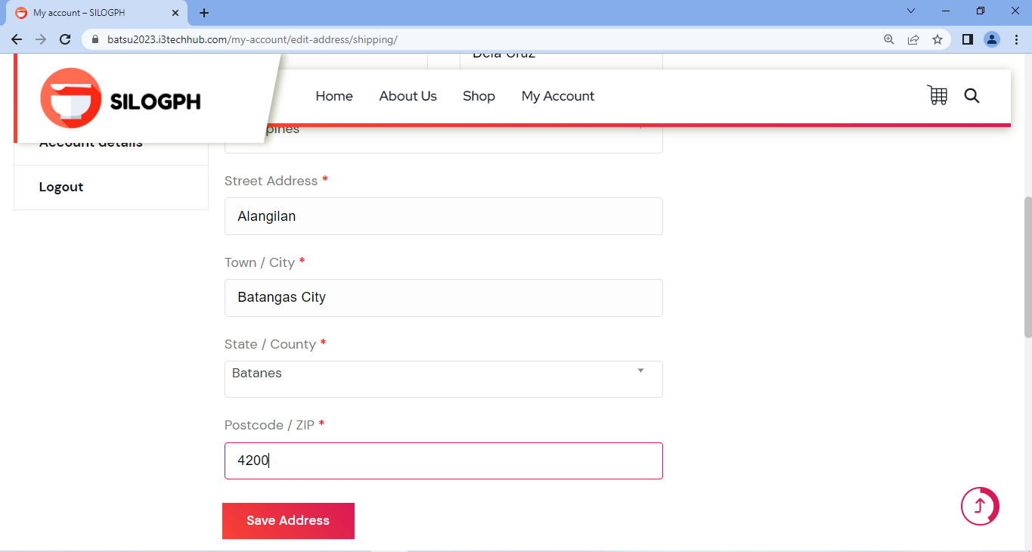

| **Field Name** | **Field Type** | **Data Type** | **Validations** | **Field Response/ Behavior** | **Mandatory** |
| --- | --- | --- | --- | --- | --- |
| User’s First Name | Text Field | String | ●   Input should be generated into the database.  ●   Input should be displayed on the Addresses section of my account page. | ● Displays the input created by the user on the Addresses section of my account page ●         Replaces the input of the user on the Addresses section of my account page upon clicking the save changes button. | No |
| User’s Last Name | Text Field | String | ●   Input should be generated into the database.  ●   Input should be displayed on the Addresses section of my account page. | ● Displays the input created by the user on the Addresses section of my account page ●         Replaces the input of the user on the Addresses section of my account page upon clicking the save | No |
| Country / Region | Dropdown list | Text | ●   Input should be generated into the database.  ● Input should be displayed on the Addresses section of my account page. | ● Displays the input created by the user on the Addresses section of my account page  ● Replaces the input of the user on the Addresses section of my account page upon clicking the save | No |
| Street Address | Text Field | Text | ●   Input should be generated into the database.  ●   Input should be displayed on the Addresses section of my account page. | ● Displays the input created by the user on the Addresses section of my account page  ● Replaces the input of the user on the Addresses section of my account page upon clicking the save changes button. | No |
| Town / City | Text Field | Text | ●   Input should be generated into the database.  ●   Input should be displayed on the Addresses section of my account page. | ● Displays the input created by the user on the Addresses section of my account page ●  Replaces the input of the user on the Addresses section of my account page upon clicking the save changes button. | No |
| State / County | Dropdown list | Text | ●   Input should be generated into the database.  ●   Input should be displayed on the Addresses section of my account page. | ● Displays the input created by the user on the Addresses section of my account page ●         Replaces the input of the user on the Addresses section of my account page upon clicking the save changes button. | No |
| Postcode / Zip Code | Integer | Integer | ●   Input should be generated into the database.  ●   I Input should be displayed on the Addresses section of my account page.  ●   Input must contain exactly 4 numbers only. | ● Displays the input created by the user on the Addresses section of my account page ●  Replaces the input of the user on the Addresses section of my account page upon clicking the save changes button.  ●Defined as a number  ●Input must contain exactly 4 numbers only. | No |

**2.2.1.7 View Home Page**

The View Home Page is a component of the system that allows the user to see various details, including the name of the website, its tagline, a description of the best seller product, and a menu.

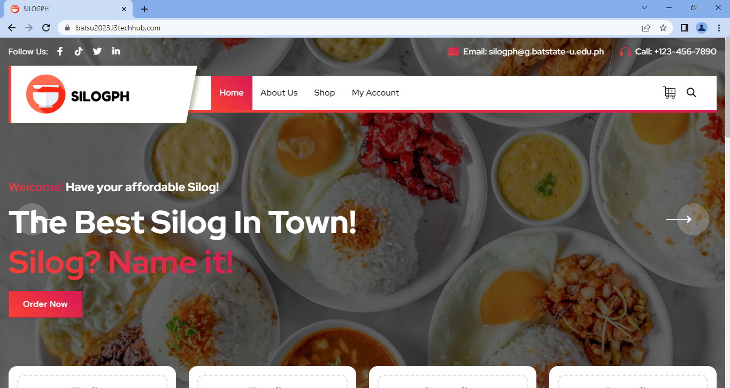

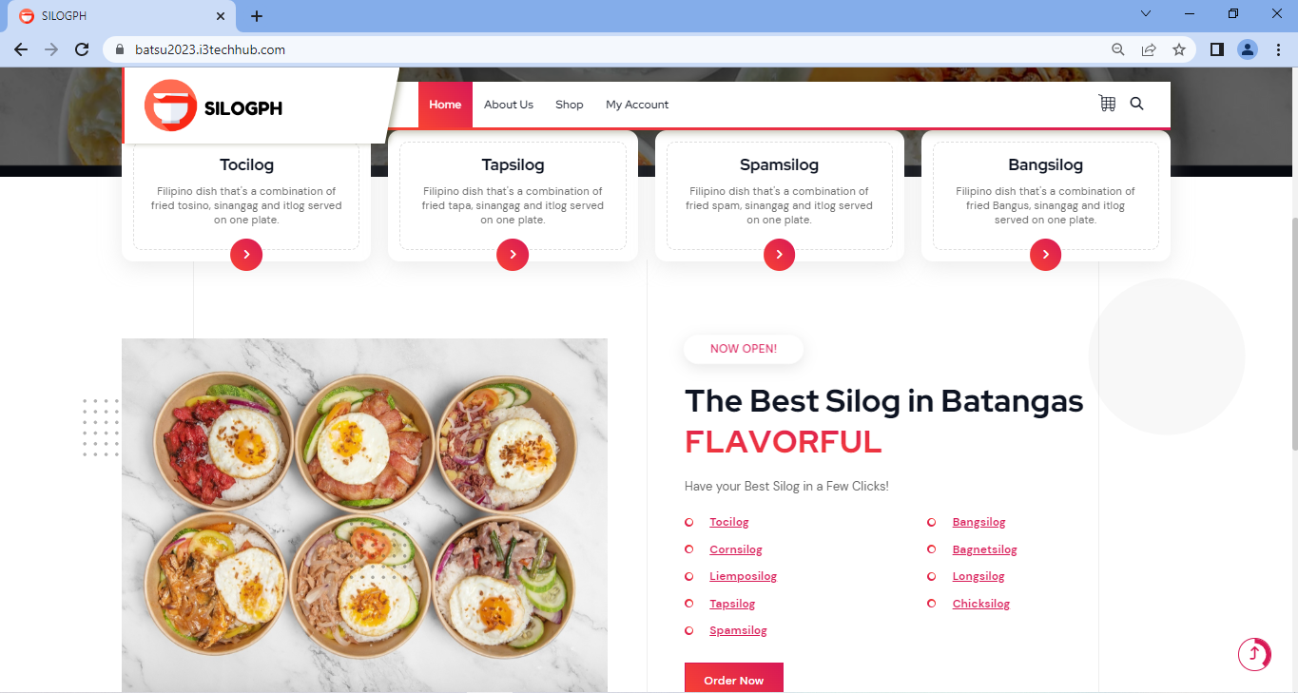

| **Field Name** | **Field Type** | **Data Type/ Length** | **Validations** | **Field Response/ Behavior** | **Mandatory** |
| --- | --- | --- | --- | --- | --- |
| Slider | Table Field | Read only | Cannot be edited | ● Slider is auto-generated | No |
| Best Seller Product Definition | Table Field | Read only | Cannot be edited | ● Best Seller Product Definition is auto-generated | No |
| Menu | Table Field | Read Only | Cannot be edited | ● Menu is auto-generated | No |

**2.2.1.8 View About Us Page**

The View About Us Page is a part of the system wherein the user can view who’s the founder of the website, how it started, and its goal.

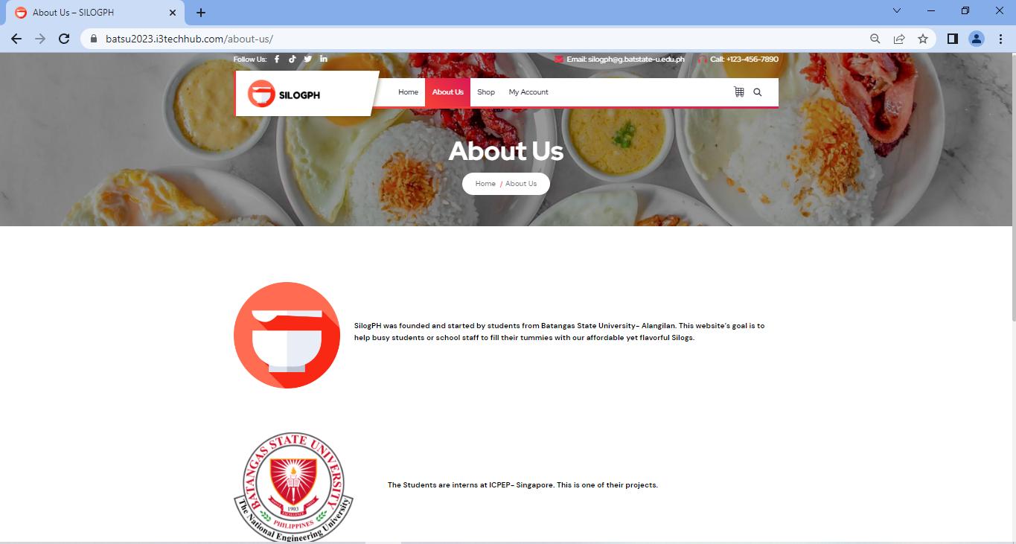

| **Field Name** | **Field Type** | **Data Type/ Lengt** | **Validations** | **Field Response/ Behavior** | **Mandatory** |
| --- | --- | --- | --- | --- | --- |
| Website Name Definition | Table Field | Read only | Cannot be edited | ● SilogPH definition is auto-generated | No |
| Website Founder | Table Field | Read only | Cannot be edited | ● Website founder  is auto-generated | No |

**2.2.1.9 View Dashboard – My Account Page**

The View Dashboard section in my account page is a part of the system wherein the user can view the recent orders, manage their shipping and billing address details, edit and update the account details, and change their password.

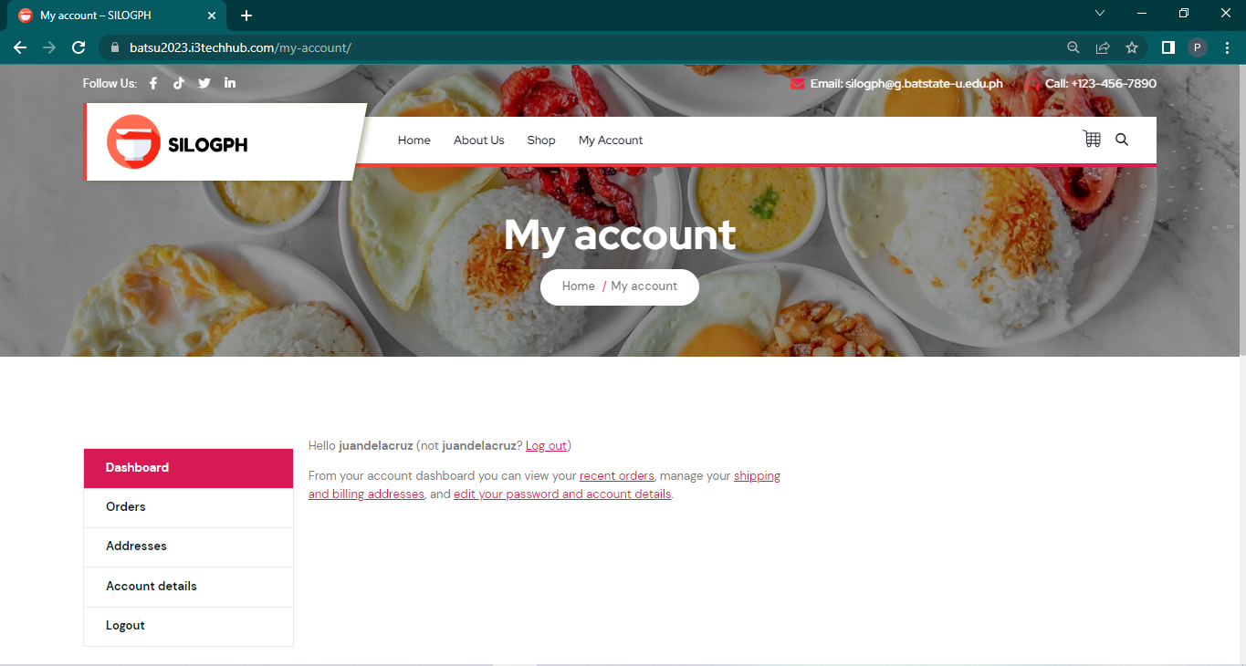

| **Field Name** | **Field**  **Type** | **Data Type/ Length** | **Validations** | **Field Response/ Behavior** | **Mandatory** |
| --- | --- | --- | --- | --- | --- |
| Dashboard | Table Field | Read only | Cannot be edited | ●Input in Dashboard section is auto-generated | No |

**2.2.1.10 View Orders – My Account Page**

The View Orders section in my account page is a part of the system wherein the user can view the order details, including the order number, date, status of the order, and the total price of the order.

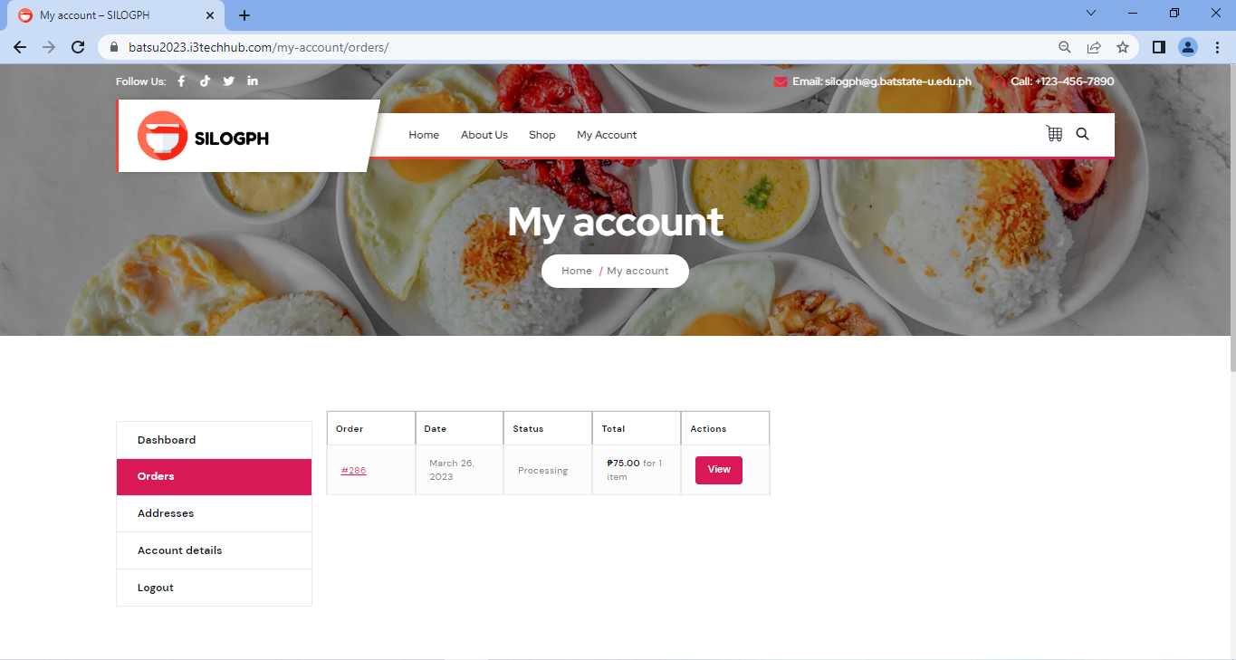

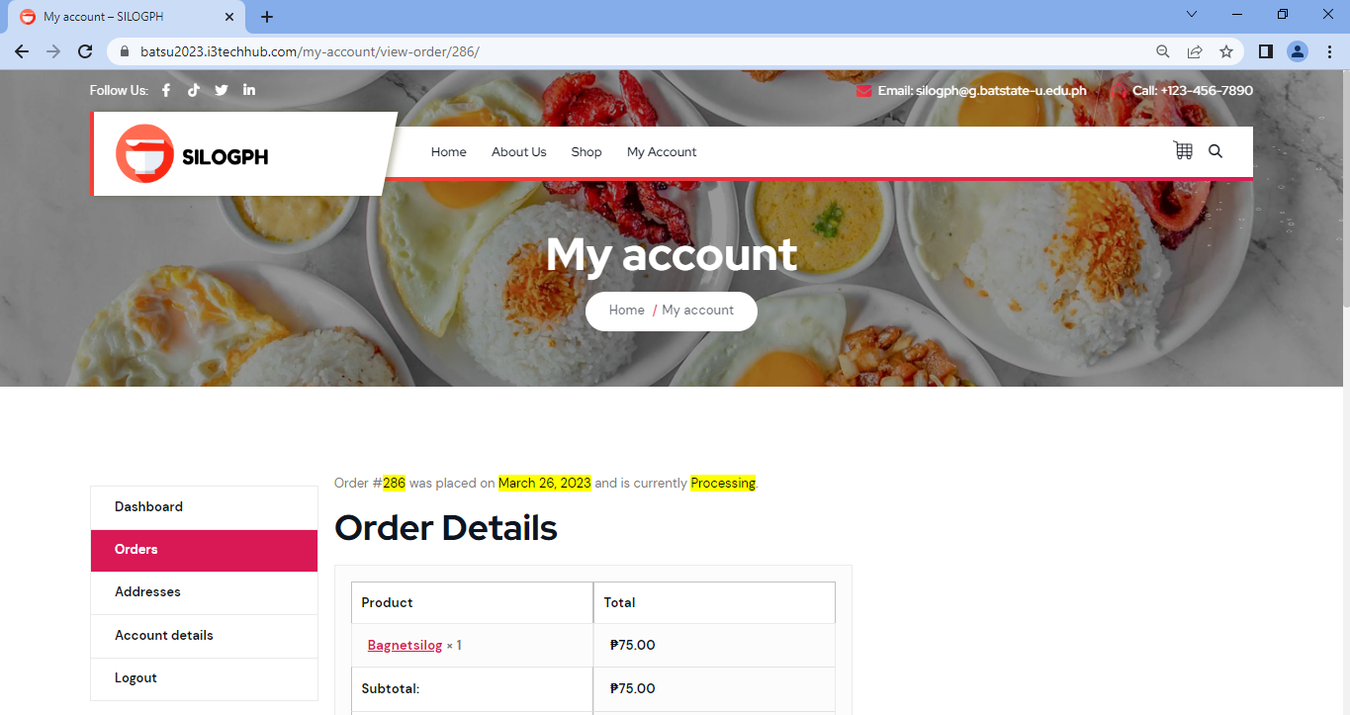

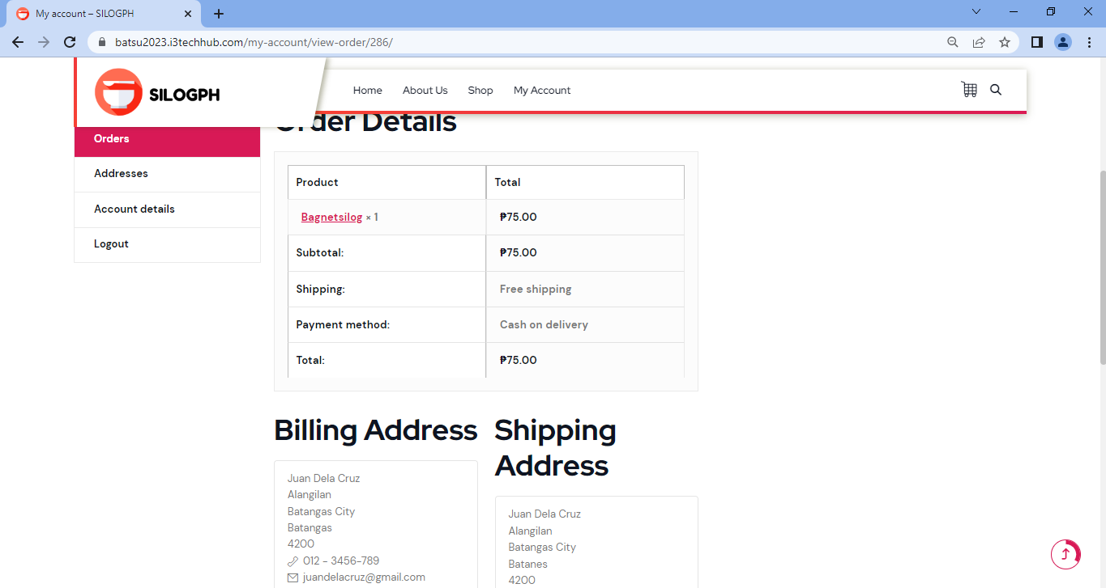

| **Field Name** | **Field Type** | **Data Type/ Length** | **Validations** | **Field Response/ Behavior** | **Mandatory** |
| --- | --- | --- | --- | --- | --- |
| Order No. | Table Field | Read only | Cannot be edited | ●Order no. in Orders section is auto-generated | No |
| Date | Table Field | Read only | Cannot be edited | ●Date in Orders section is auto-generated | No |
| Status | Table Field | Read only | Cannot be edited | ●Status in Orders section is auto-generated | No |
| Total | Table Field | Read only | Cannot be edited | ●Total in Orders section is auto-generated | No |
| Actions | Table Field | Read only | Cannot be edited | ●Actions in Orders section is auto-generated | No |
| Product | Table Field | Read only | Cannot be edited | ●Product in Orders section is auto-generated | No |
| Price | Table Field | Read only | Cannot be edited | ●Price in Orders section is auto-generated | No |
| SubTotal | Table Field | Read only | Cannot be edited | ●Sub Total in Orders section is auto-generated | No |

**2.2.1.11 View Addresses – My Account Page**

The View Addresses section in my account page is a part of the system wherein the user can view the complete details of billing and shipping address details.

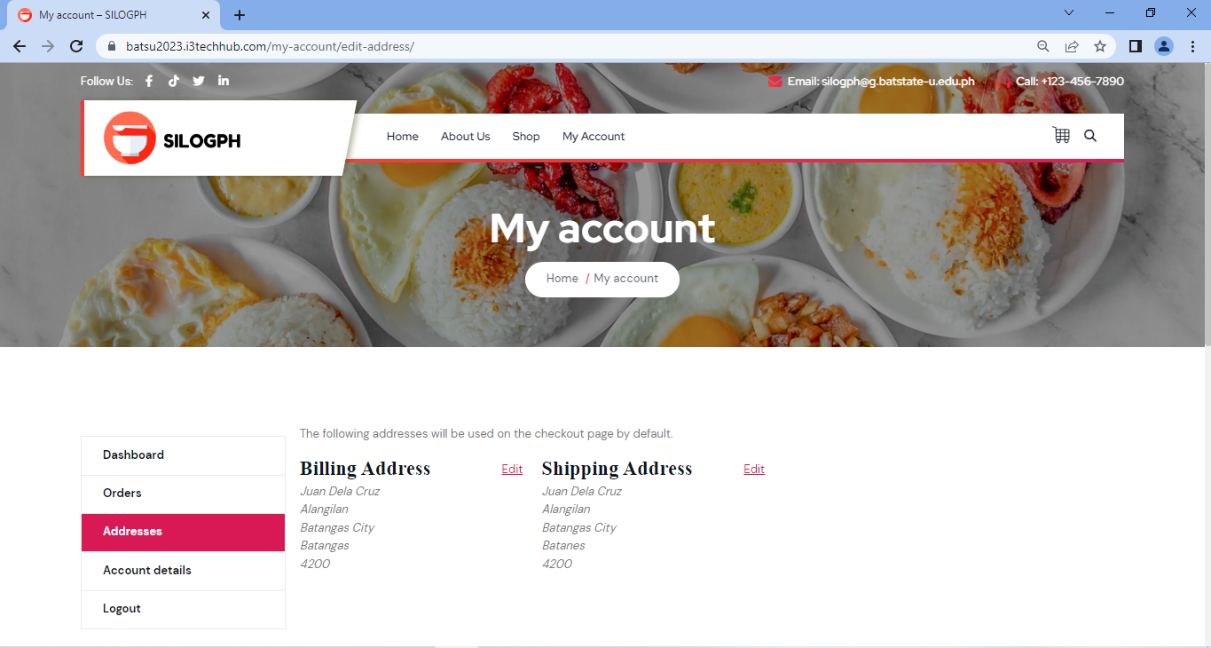

| **Field Name** | **Field Type** | **Data Type/ Length** | **Validations** | **Field Response/ Behavior** | **Mandatory** |
| --- | --- | --- | --- | --- | --- |
| Billing Address | Table Field | Read only | Cannot be edited | ●Billing Address in addresses section is auto-generated | No |
| Shipping Address | Table Field | Read only | Cannot be edited | ●Shipping Address in addresses section is auto-generated | No |

**2.2.1.12 View Account Details – My Account Page**

The View Cart page is a system component that displays the quantity of a product added to the cart as well as its price, cart totals, and shipping address information. The user has the option of changing the quantity of their order as well as the delivery address.





| **Field Name** | **Field Type** | **Data Type** | **Validations** | **Field Response/ Behavior** | **Mandatory** |
| --- | --- | --- | --- | --- | --- |
| User Name | Table Field | Read and edit | ●   Can be edited | ● Displays the input created by the user on the account details section of my account page. | Yes |
| First Name | Table Field | Read and edit | ●   Can be edited | ● Displays the input created by the user on the account details section of my account page. | Yes |
| Last Name | Table Field | Read and edit | ●   Can be edited | ● Displays the input created by the user on the account details section of my account page. | Yes |
| Email Address | Table Field | Read and edit | ●   Can be edited | ● Displays the input created by the user upon registration on the account details section of my account page. | Yes |
| Current password | Table Field | Read and edit | ●   Can be edited | ● Can display the current password entered by the user | Yes |
| New password | Table Field | Read and edit | ●   Can be edited | ● Can display the new password entered by the user | Yes |
| Confirm Password | Table Field | Read and edit | ●   Can be edited | ● Can display the confirm password entered by the user | Yes |

**2.2.1.13 View Shop Page**

The View Shop Page is a part of the system wherein the user can view the available products with their prices, and add products to their cart.

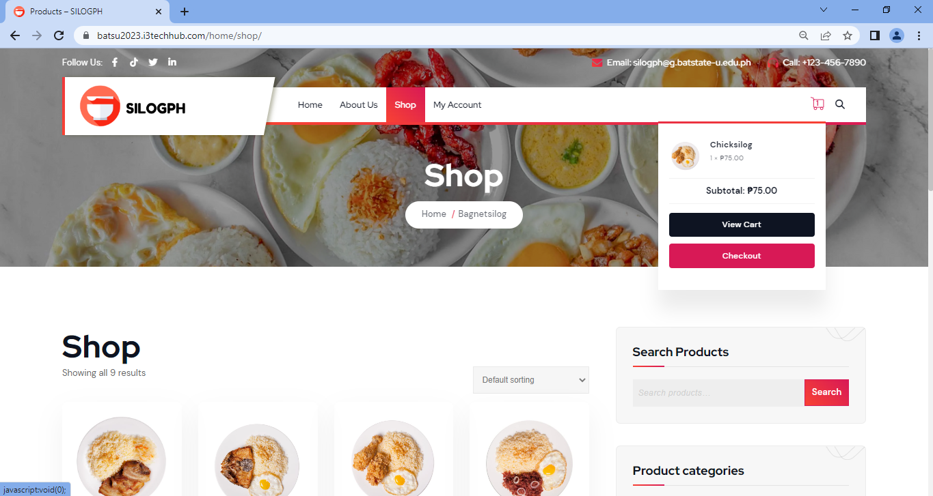

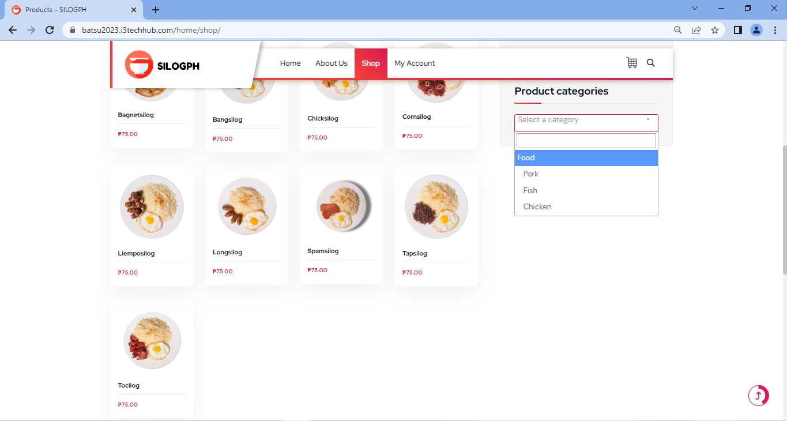

| **Field Name** | **Field Type** | **Data Type** | **Validations** | **Field Response/ Behavior** | **Mandatory** |
| --- | --- | --- | --- | --- | --- |
| Showing all products | Table Field | Read only | Cannot be edited | ● Displays all the products available | No |
| Product Categories | Table Field | Read only | Cannot be edited | ● Display the product categories | No |
| Search Product | Table Field | Read only | Cannot be edited | ● Display the specific product upon clicking the search button | No |
| Browse Product | Table Field | Read only | Cannot be edited | ● Display all the products available | No |

**2.2.1.14 View Cart Page**

The View Cart page is part of the system wherein the user can view and edit the quantity of the product added to cart, user can view its price, cart totals and the shipping address information

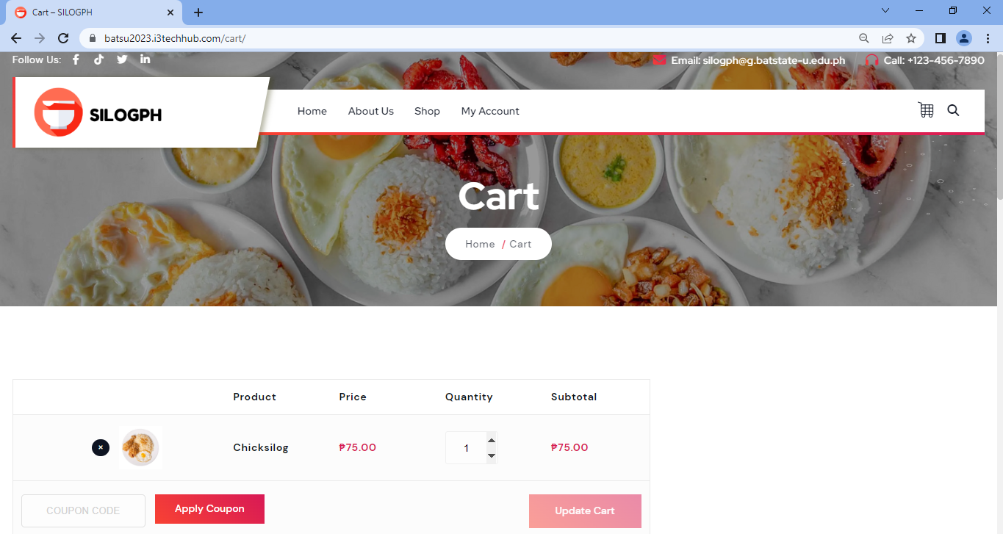

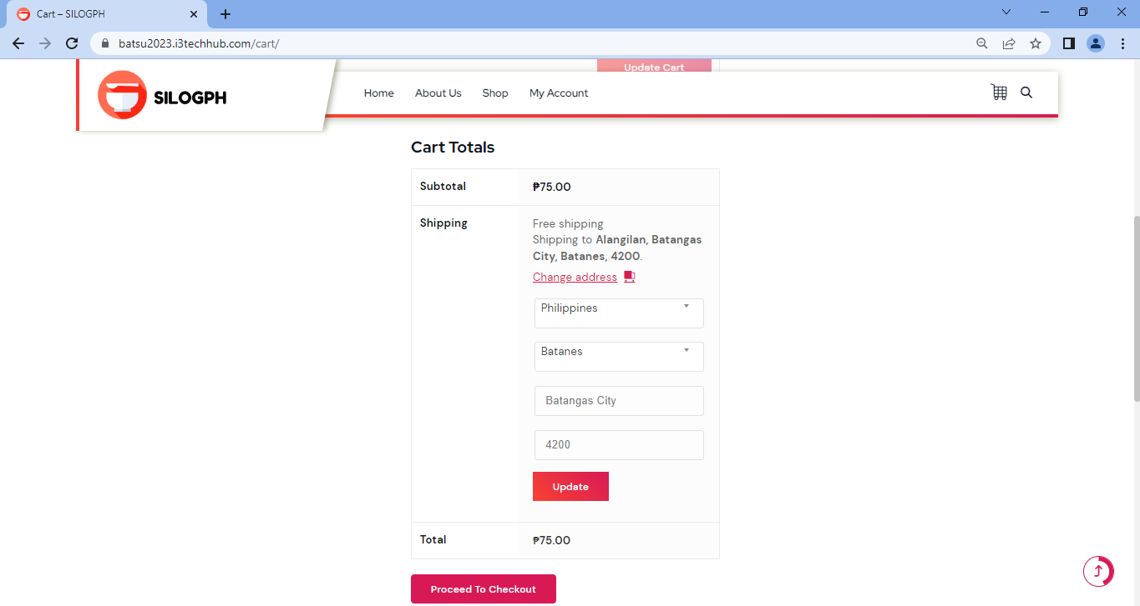

| **Field Name** | **Field Type** | **Data Type** | **Validations** | **Field Response/ Behavior** | **Mandatory** |
| --- | --- | --- | --- | --- | --- |
| Add/Remove Product | Table Field |  | Can be edited | ● Display the product you added/removed from your cart, and if there are any changes, click the update cart button. | No |
| Price | Table Field | Read only | Cannot be edited | ● Price in the cart page is auto generated | No |
| Quantity | Table Field | Read and edit | Can be edited | ● Display the quantity entered by the user in Cart page. | No |
| Cart Totals | Table Field | Read only | Cannot be edited | ● Sub Total and Total in the cart page is auto generated | No |
| Coupon | Table Field | Read and Edit | Can be edited | ● Coupon will auto generate if the coupon code is valid. | No |
| Shipping Address | Table Field | Read and Edit | Can be edited | ● Displays the input entered by the user upon adding a shipping address to the addresses section of my account page. | No |

**2.2.1.15 View Checkout Page**

The View Checkout Page allows the user to view the summary of his/her orders, the billing details where it can be modified before proceeding to placing order. After the order is placed, the page will show the summary of the user’s order and billing address where it cannot be changed anymore.

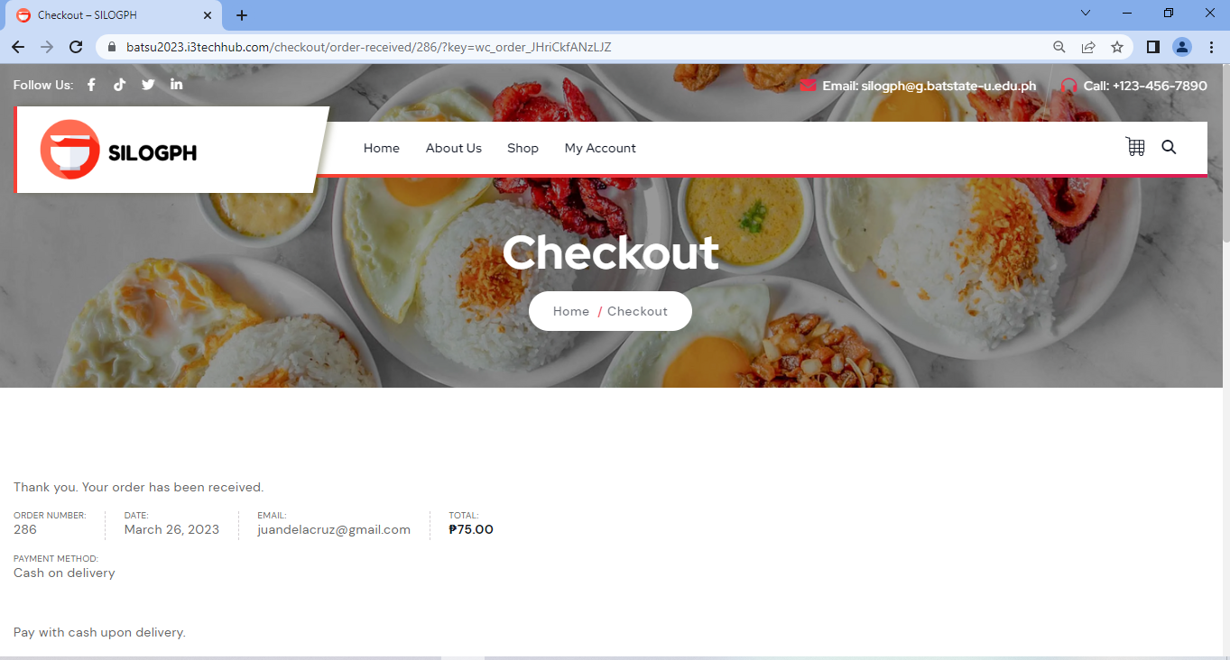

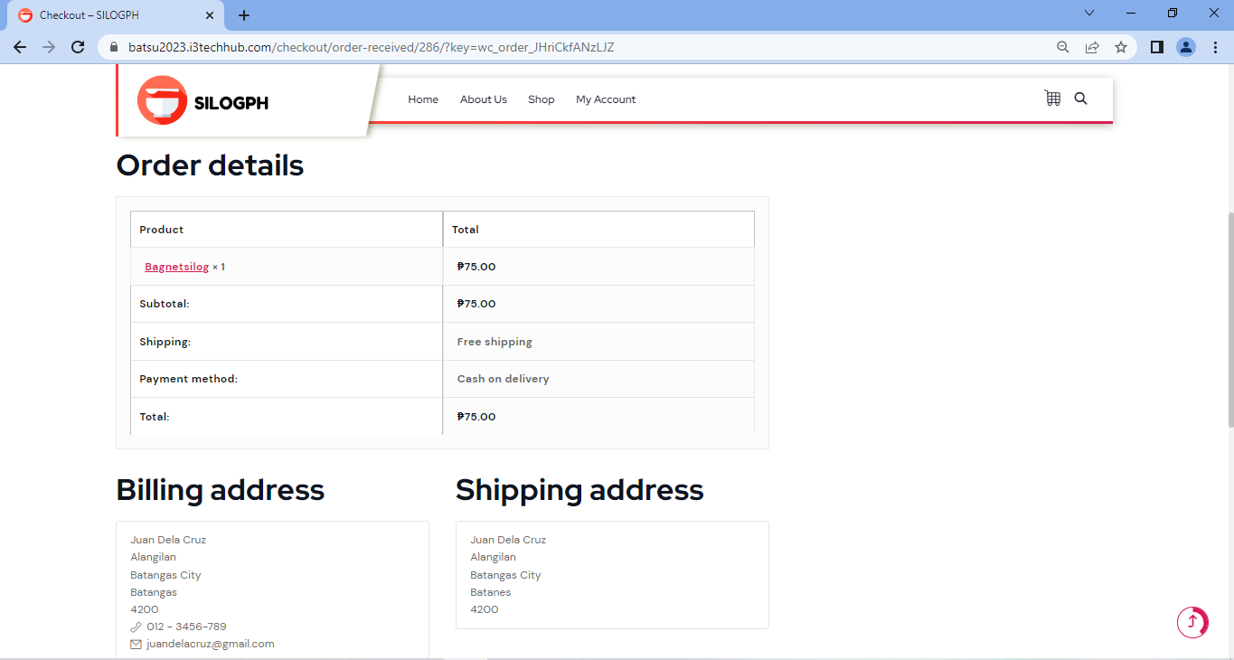

| **Field Name** | **Field Type** | **Data Type** | **Validations** | **Field Response/ Behavior** | **Mandatory** |
| --- | --- | --- | --- | --- | --- |
| Order Confirmation | Text Field | Text | ● Cannot be edited. | ●     Order Confirmation is auto generated | No |
| Order Number | Table Type | Read only | ● Cannot be edited. | ●Order Number is auto generated. | No |
| Email | String | Read only | ● Cannot be edited. | ●Email is auto generated. | No |
| Date | Date | Read only | ● Cannot be edited. | ●Date is auto generated. | No |
| Total | Table Type | Read only | ● Cannot be edited. | ●Total is auto generated. | No |
| Payment Method | Table Type | Read only | ● Cannot be edited. | ●Payment method is auto generated. | No |
| Order Details -Product | Table Type | Read only | ● Cannot be edited. | ●Product is auto generated. | No |
| Order Details - Price | Table Type | Read only | ● Cannot be edited. | ●Price is auto generated. | No |
| Order Details - Sub Total | Table Type | Read only | ● Cannot be edited. | ●subTotal is auto generated. | No |
| Order Details - Shipping | Table Type | Read only | ● Cannot be edited. | ●Shipping is auto generated. | No |
| Order Details - Payment Method | Table Type | Read only | ● Cannot be edited. | ●Payment method is auto generated. | No |
| Order Details - Total | Table Type | Read only | ● Cannot be edited. | ●Total is auto generated. | No |
| User’s First Name  Billing Details | Text Field | String | ● Cannot be edited. | ●First name is auto generated. | Yes |
| User’s Last Name  Billing Details | Text Field | String | ● Cannot be edited. | ●Last name is auto generated. | Yes |
| Country / Region  Billing Details | Dropdown list | Text | ● Cannot be edited. | ●Country / Region is auto generated. | Yes |
| Street Address  Billing Details | Text Field | Text | ● Cannot be edited. | ●Street is auto generated. | Yes |
| Town / City  Billing Details | Dropdown list | Text | ● Cannot be edited. | ●Town / City is auto generated. | Yes |
| State / County  Billing Details | Text Field | Text | ● Cannot be edited. | ●State / County is auto generated. | Yes |
| Postcode / Zip Code  Billing Details | Integer | Integer | ● Cannot be edited. | ●Postcode/Zipcode is auto generated. | Yes |
| Phone Number  Billing Details | Text Field | String | ● Cannot be edited. | ●Phone Number is auto generated. | Yes |
| User’s email address  Billing Details | Text Field | String | ● Cannot be edited. | ●Email address is auto generated. | Yes |
| User’s First Name  Ship to different address | Text Field | String | ● Cannot be edited. | ●First name is auto generated. | Yes |
| User’s Last Name  Ship to different address | Text Field | String | ● Cannot be edited. | ●Last name is auto generated. | Yes |
| Country / Region  Ship to different address | Dropdown list | Text | ● Cannot be edited. | ●Country / Region is auto generated. | Yes |
| Street Address  Ship to different address | Text Field | Text | ● Cannot be edited. | ●Street is auto generated. | Yes |
| Town / City  Ship to different address | Dropdown list | Text | ● Cannot be edited. | ●Town / City is auto generated. | Yes |
| State / County  Ship to different address | Text Field | Text | ● Cannot be edited. | ●State / County is auto generated. | Yes |
| Postcode / Zip Code  Ship to different address | Integer | Integer | ● Cannot be edited. | ●Postcode/Zipcode is auto generated. | Yes |

**2.2.2 Admin Module Screen and Field Layout**

**2.2.2.1 Edit Website Product Page**

The Edit Website Product Page is a component of the system that allows the administrator to input and update information on the Product Page. This includes the product name, product description, product data, product short description, publishing options, product image, product gallery, product categories, product tags, and channel visibility.

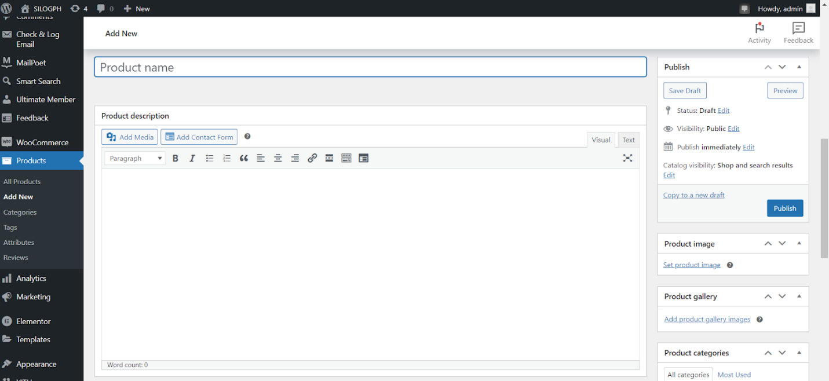

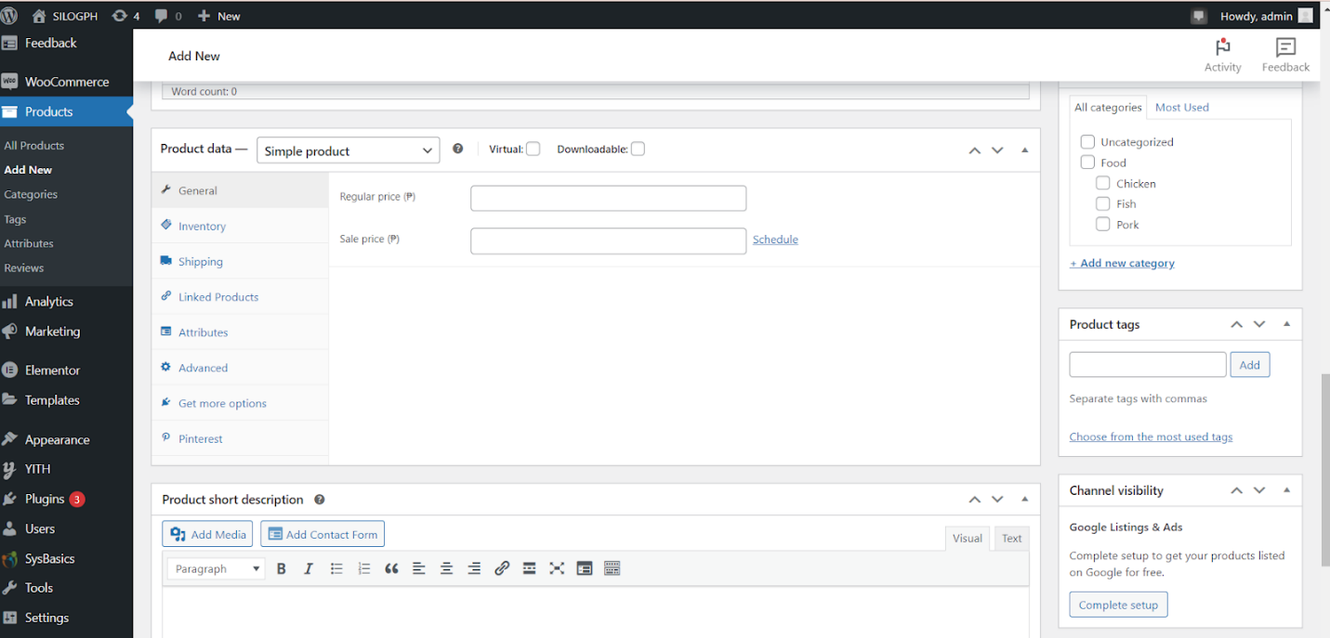

| **Field Name** | **Field Type** | **Data Type** | **Validations** | **Field Response/ Behavior** | **Mandatory** |
| --- | --- | --- | --- | --- | --- |
| Product Name | Text Field | String | ● Input should be generated into the database.  ● Input should be displayed on the product page. | ● Displays <blank> option by default.  ● Add a potential name for the new silog product. | Yes |
| Product Description | Text Field | String | ● Input should be generated into the database.  ● Input should be displayed on the product page. | ●The default option shown is <blank> and the administrator can provide a description for a new product. | Yes |
| Product Data | Text Field | String | ● Input should be generated into the database.  ● Input should be displayed on the product page. | ● By default, the <blank> option is displayed, and the administrator has the option to select the product type from the dropdown list, as well as choose whether it is a virtual or downloadable product.  ● The regular and sale prices are visible, and the administrator can enter the price of the product. | Yes |
| Product Short Description | Text Field | String | ● Input should be generated into the database.  ● Input should be displayed on the product page. | ● The default option shown is <blank> and the administrator can provide a short description for a new product. | Yes |
| Publish | Drop-down list | Text | ● Input should be generated into the database.  ● Input should be displayed on the product page. | ● This section shows the status, visibility, publish immediately, and shop and results options, and only the administrator has the ability to edit and create a draft before publishing it. | Yes |
| Product image | Table Field | Edit | ● Input should be generated into the database.  ● Input should be displayed on the product page. | ● The administrator can upload an image for the product page of a newly added product. | Yes |
| Product gallery | Table Field | Edit | ● Input should be generated into the database.  ● Input should be displayed on the product page. | ● The administrator can add product gallery images for the product page of newly added products. | Yes |
| Product categories | Drop-down list | Text | ● Input should be generated into the database.  ● Input should be displayed on the product page. | ● This section allows the administrator to create a new product category and also modify existing categories. | Yes |
| Product tags | Table Field | String | ● Input should be generated into the database.  ● Input should be displayed on the product page. | ● The default option displayed is <blank>, and the administrator has the option to add tags and choose from the most commonly used ones. | Yes |
| Channel visibility | Table Field | String | ● Input should be generated into the database.  ● Input should be displayed on the product page. | ● This section displays the complete setup option, which only the administrator can select to have the products listed on Google for free. | Yes |

**2.2.2.2 View Website Product Page**

The View Website Product Page is a component of the system that allows admin to access and review a range of information about the silog products that are showcased on the website. These details may include the names of the products, the available stock, pricing information, categories and tags assigned to the products, the publication dates, and various statistics related to the products.

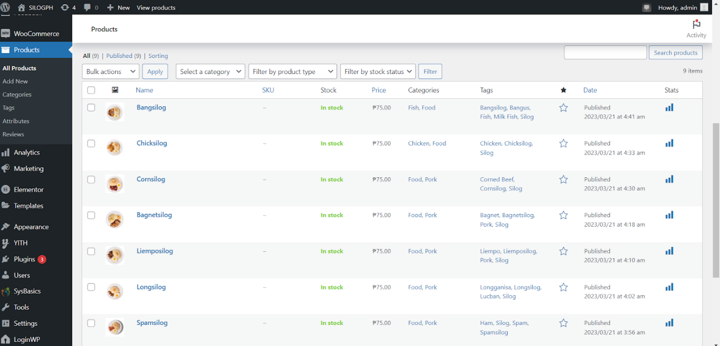

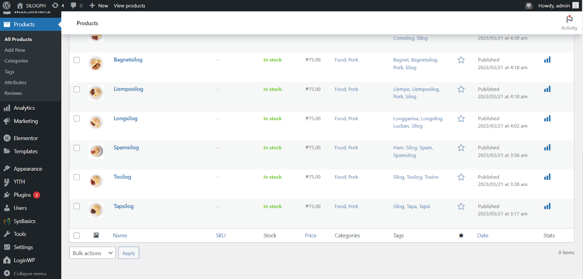

| **Field Name** | **Field Type** | **Data Type** | **Validations** | **Field Response/ Behavior** | **Mandatory** |
| --- | --- | --- | --- | --- | --- |
| Name | Table Field | Read only | ●   Cannot be edited | ● Displays various names for silog meals. | No |
| Stock | Table Field | Read only | ●   Cannot be edited | ● Indicates whether the item is presently available for purchase by displaying "in stock" or "no stock”. | No |
| Price | Table Field | Read only | ●   Cannot be edited | ●   Shows the particular cost of every silog item. | No |
| Categories | Table Field | Read only | ●   Cannot be edited | ● Displays the distinct classification of Silog products, which may include fish, pork, chicken, and other types of food. | No |
| Tags | Table Field | Read only | ●   Cannot be edited | ● Displays the precise ingredients utilized in each silog meal. | No |
| Date | Table Field | Read only | ●   Cannot be edited | ● Displays the time and date that each product was published. | No |
| Stats | Table Field | Read only | ●   Cannot be edited | ●Displays the product's statistics. | No |

**2.2.2.3 View Order Page**

The View Order Page is a part of the system that is accessible by the admin, and it allows them to review various details related to the customer's order. These details may include the order date, current status, billing and shipping information, total cost, and an action button that signifies the completion of the order with a checkmark icon.

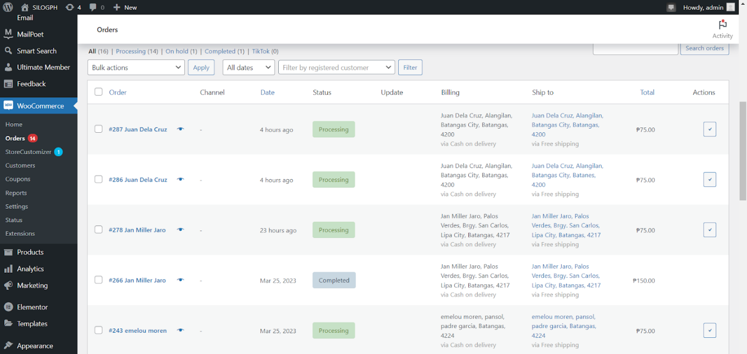

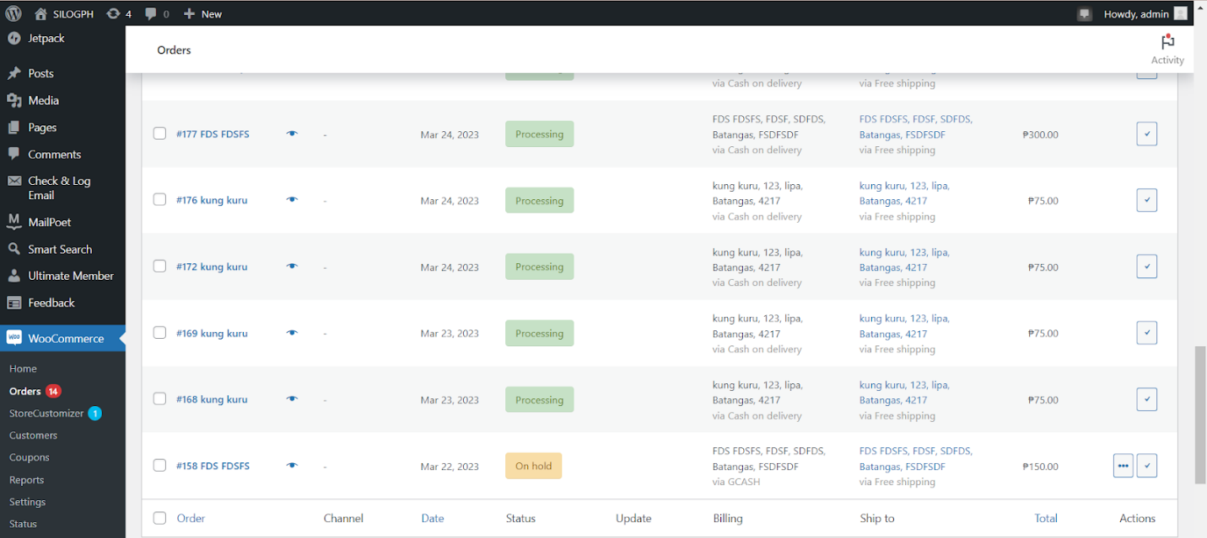

| **Field Name** | **Field Type** | **Data Type** | **Validations** | **Field Response/ Behavior** | **Mandatory** |
| --- | --- | --- | --- | --- | --- |
| Order | Table Field | Read only | ●   Cannot be edited | ● Shows the customer's name and their assigned sequence number. | No |
| Date | Table Field | Read only | ●   Cannot be edited | ●      Display the time or date when the customer made their order. | No |
| Status | Table Field | Read only | ●   Cannot be edited | ●     Displays the status of an order, such as whether it is currently being processed, already completed, or other relevant updates. | No |
| Billing | Table Field | Read only | ●   Cannot be edited | ●      Displays the customer's billing details, which may include their name, address, and the payment method they used for their purchase. | No |
| Ship to | Table Field | Read only | ●Cannot be edited | ●   Displays where the order will be shipped, including the name and address. | No |
| Total | Table Field | Read only | ●Cannot be edited | ● Shows the total cost of the order, with the currency symbol for Philippine Peso (₱) included. | No |
| Action | Table Field | Read only | ●   Cannot be edited | ● Shows a checkmark icon to indicate that the order is completed. | No |

**2.2.2.4 View Customer Details**

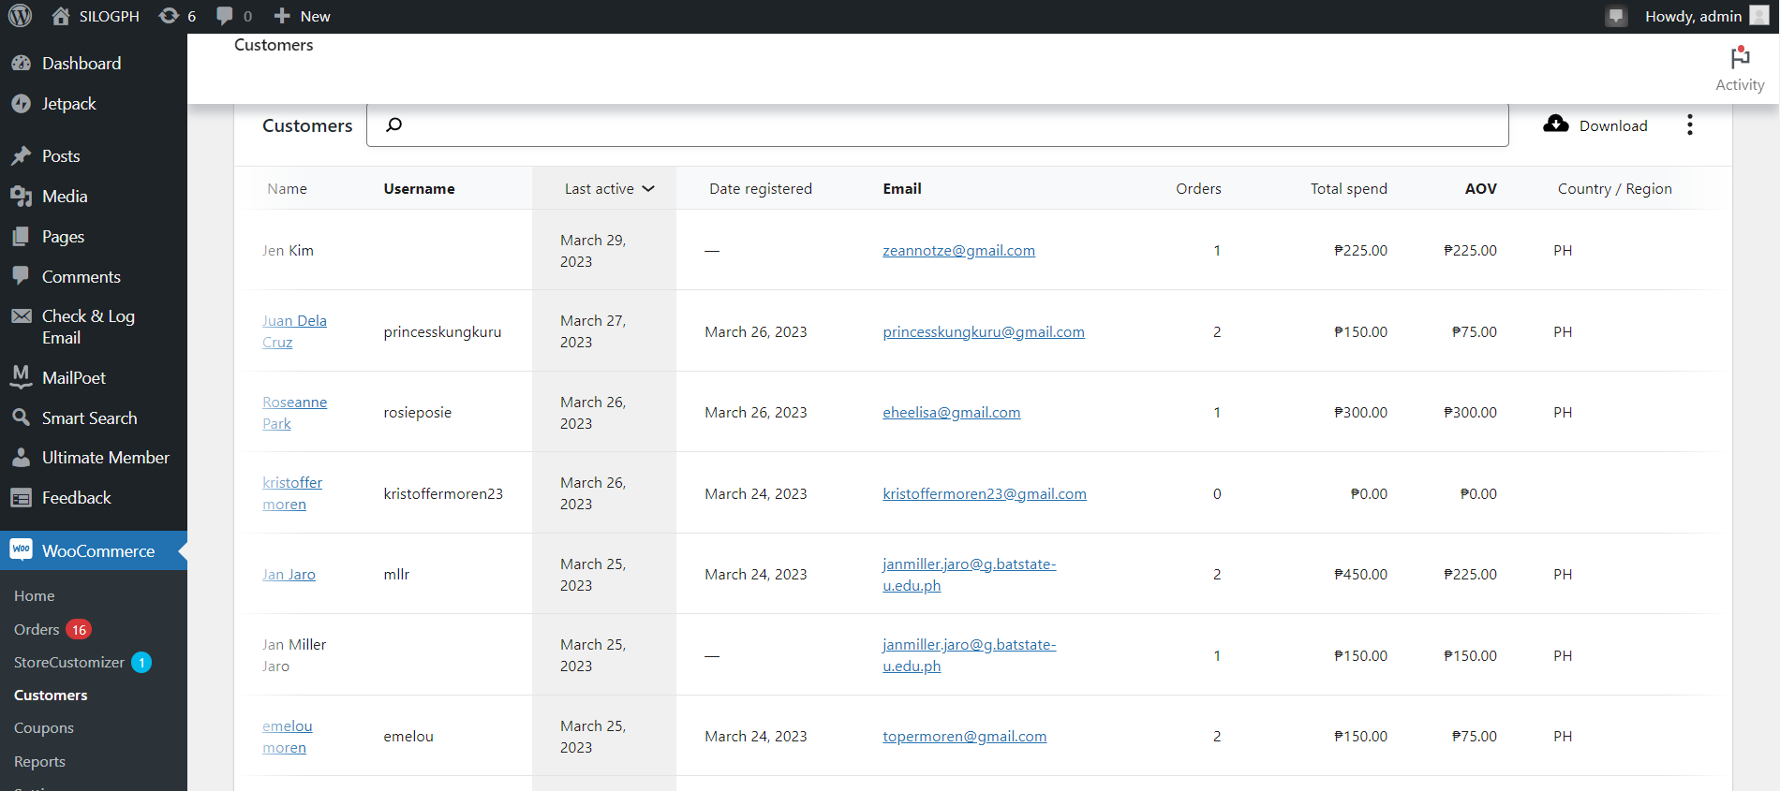

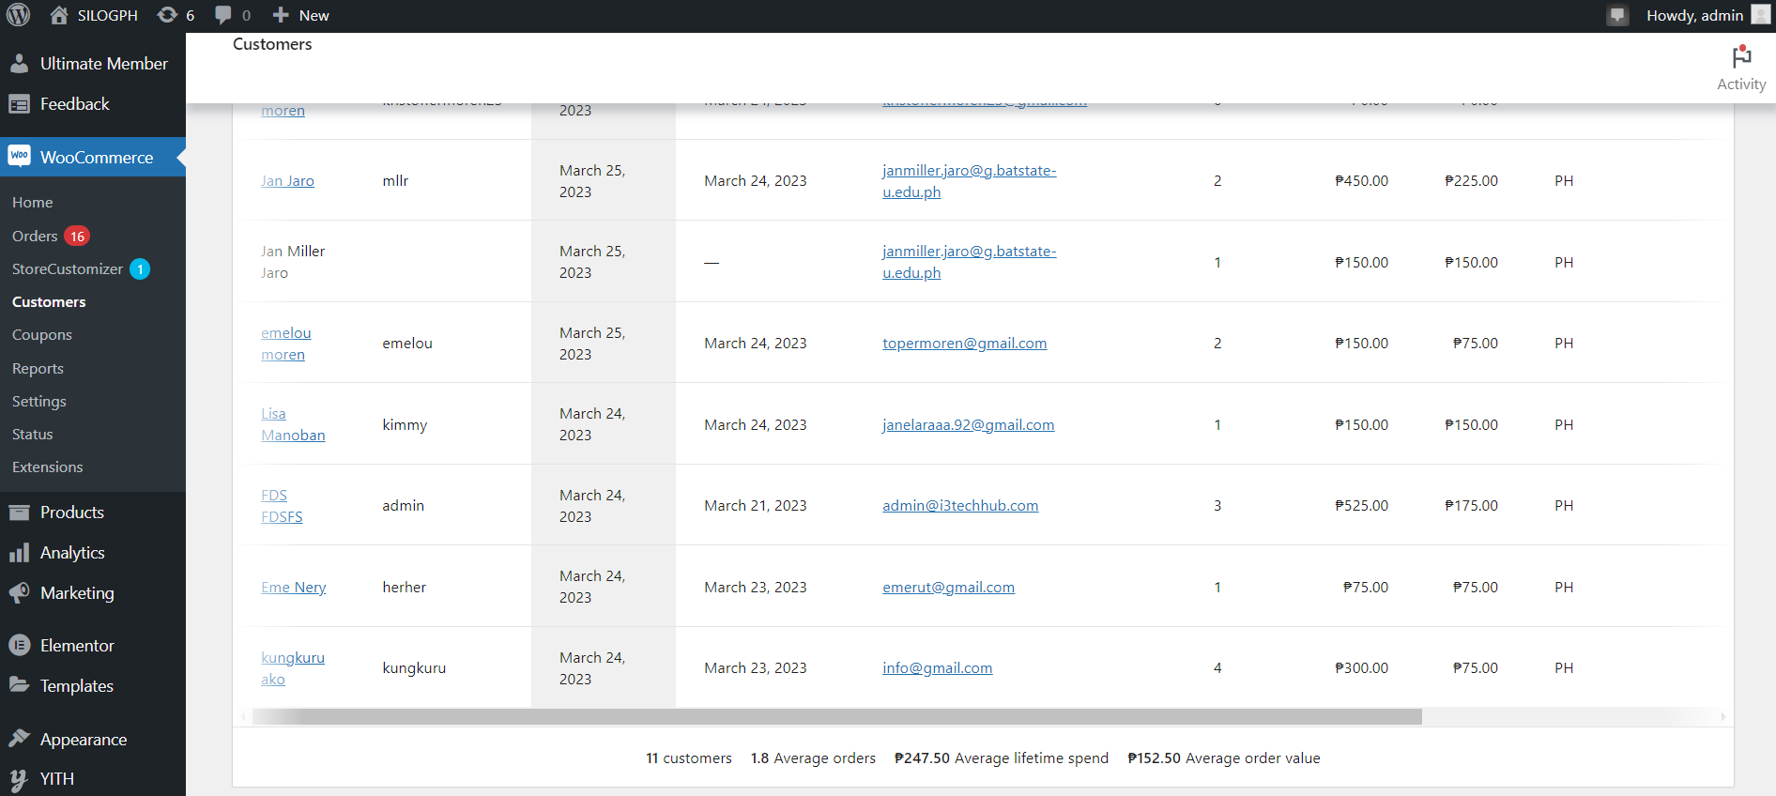

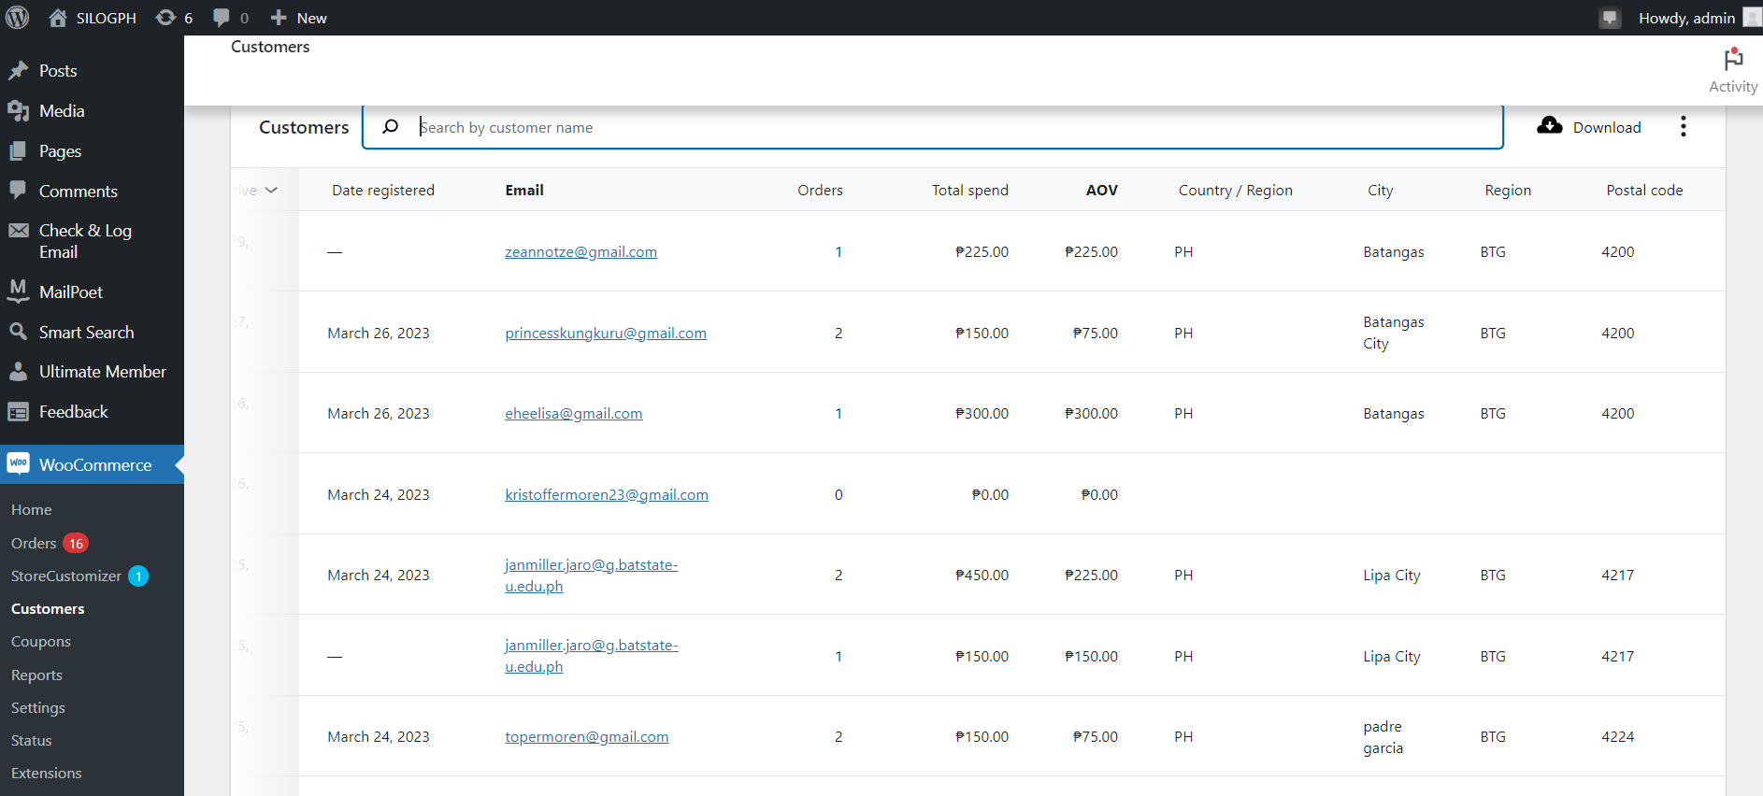

| **Field Name** | **Field Type** | **Data Type** | **Validations** | **Field Response/ Behavior** | **Mandatory** |
| --- | --- | --- | --- | --- | --- |
| Name | Table Field | Read only | ●   Cannot be edited | ● Displays the names of the customers. | No |
| Username | Table Field | Read only | ●   Cannot be edited | ● Displays the username of the customer. | No |
| Last active | Table Field | Read only | ●   Cannot be edited | ●   Displays when is the last time the customers are active. | No |
| Date registered | Table Field | Read only | ●   Cannot be edited | ● Displays the date when the customers registered. | No |
| Email | Table Field | Read only | ●   Cannot be edited | ● Displays the email input by the customer. | No |
| Orders | Table Field | Read only | ●   Cannot be edited | ● Displays the total number of orders made by the customers. | No |
| Total spend | Table Field | Read only | ●   Cannot be edited | ● Displays the total amount spend by of the customers. | No |
| AOV | Table Field | Read only | ●   Cannot be edited | ● Displays the average order value of the customers. | No |
| Country / Region | Table Field | Read only | ●   Cannot be edited | ● Displays the country where the customers are located. | No |

**2.2.2.5 View Products Analytics**

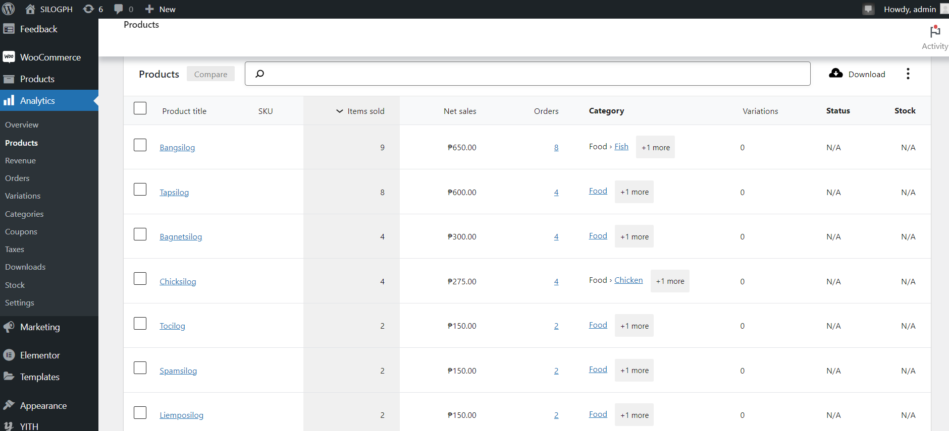

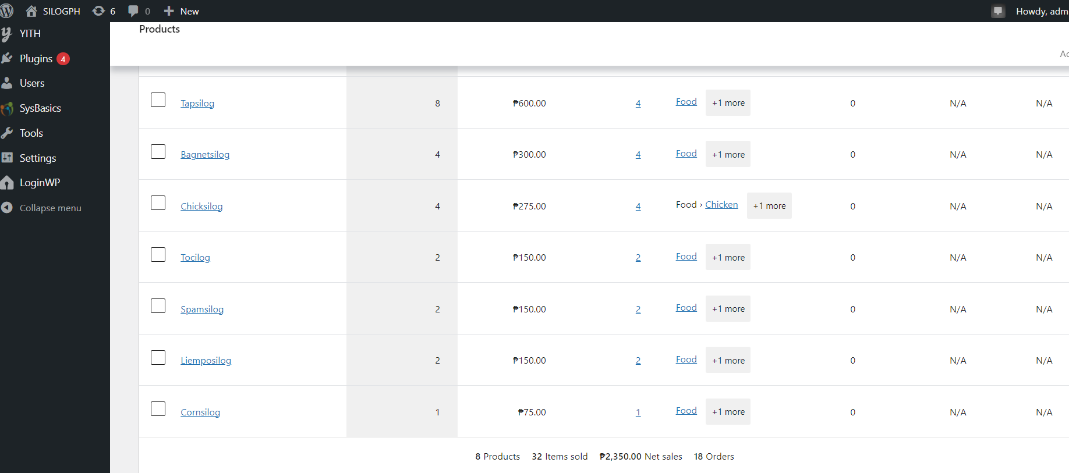

| **Field Name** | **Field Type** | **Data Type** | **Validations** | **Field Response/ Behavior** | **Mandatory** |
| --- | --- | --- | --- | --- | --- |
| Product title | Table Field | Read only | ●   Cannot be edited | ● Displays the title of the product. | No |
| Items sold | Table Field | Read only | ●   Cannot be edited | ● Displays the number of sold within the date range. | No |
| Net sales | Table Field | Read only | ●   Cannot be edited | ●   Displays the total amount of sales without any deductions within the date range. | No |
| Orders | Table Field | Read only | ●   Cannot be edited | ● Displays the number of orders in each item within the date range. | No |
| Category | Table Field | Read only | ●   Cannot be edited | ● Displays the category of the product. | No |
| Variations | Table Field | Read only | ●   Cannot be edited | ● Displays the variation of the product. | No |
| Status | Table Field | Read only | ●   Cannot be edited | ●Displays the status of the product. | No |
| Stock | Table Field | Read only | ●   Cannot be edited | ●Displays the stock of the product. | No |

**2.2.2.5 View Revenue Analytics**

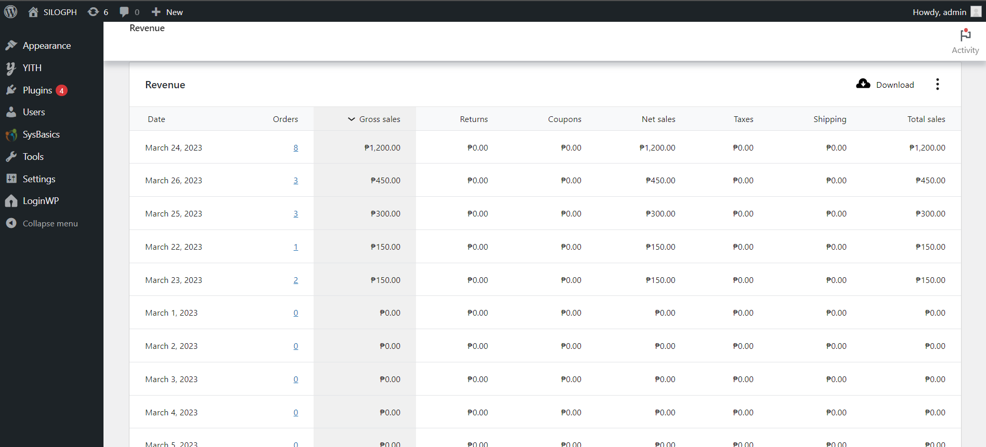

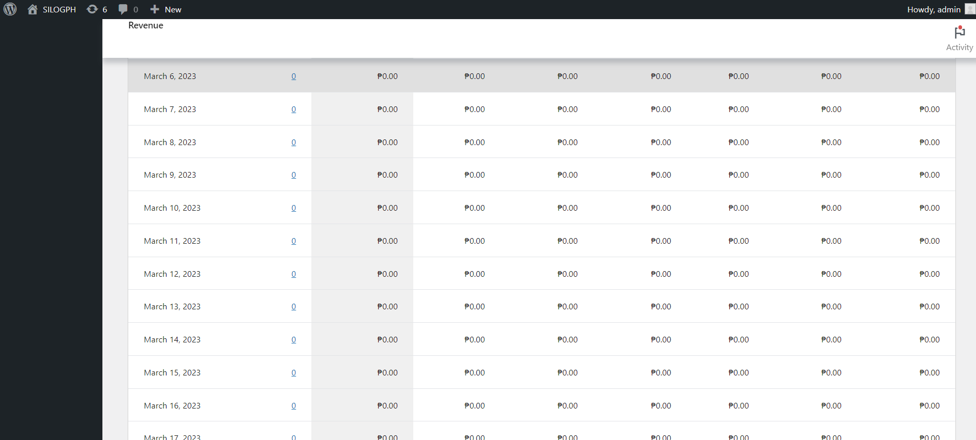

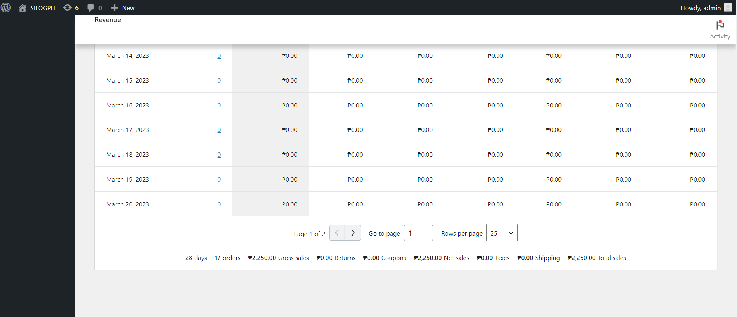

| **Field Name** | **Field Type** | **Data Type** | **Validations** | **Field Response/ Behavior** | **Mandatory** |
| --- | --- | --- | --- | --- | --- |
| Date | Table Field | Read only | ●   Cannot be edited | ● Displays the date when there are orders made. | No |
| Orders | Table Field | Read only | ●   Cannot be edited | ● Displays the number of orders received on a day. | No |
| Gross Sales | Table Field | Read only | ●   Cannot be edited | ●   Displays the total amount of sales without any deductions. | No |
| Returns | Table Field | Read only | ●   Cannot be edited | ● Displays the value of returns. | No |
| Coupons | Table Field | Read only | ●   Cannot be edited | ● Displays the value of coupons. | No |
| Net sales | Table Field | Read only | ●   Cannot be edited | ● Displays the sum of gross sales minus returns, and taxes. | No |
| Taxes | Table Field | Read only | ●   Cannot be edited | ●Displays the taxes per order. | No |
| Shipping | Table Field | Read only | ●   Cannot be edited | ●Displays the value of shipping fee per order. | No |
| Total sales | Table Field | Read only | ●   Cannot be edited | ●Displays the total amount of revenue from sales. | No |

**2.2.2.6 View Order Analytics**

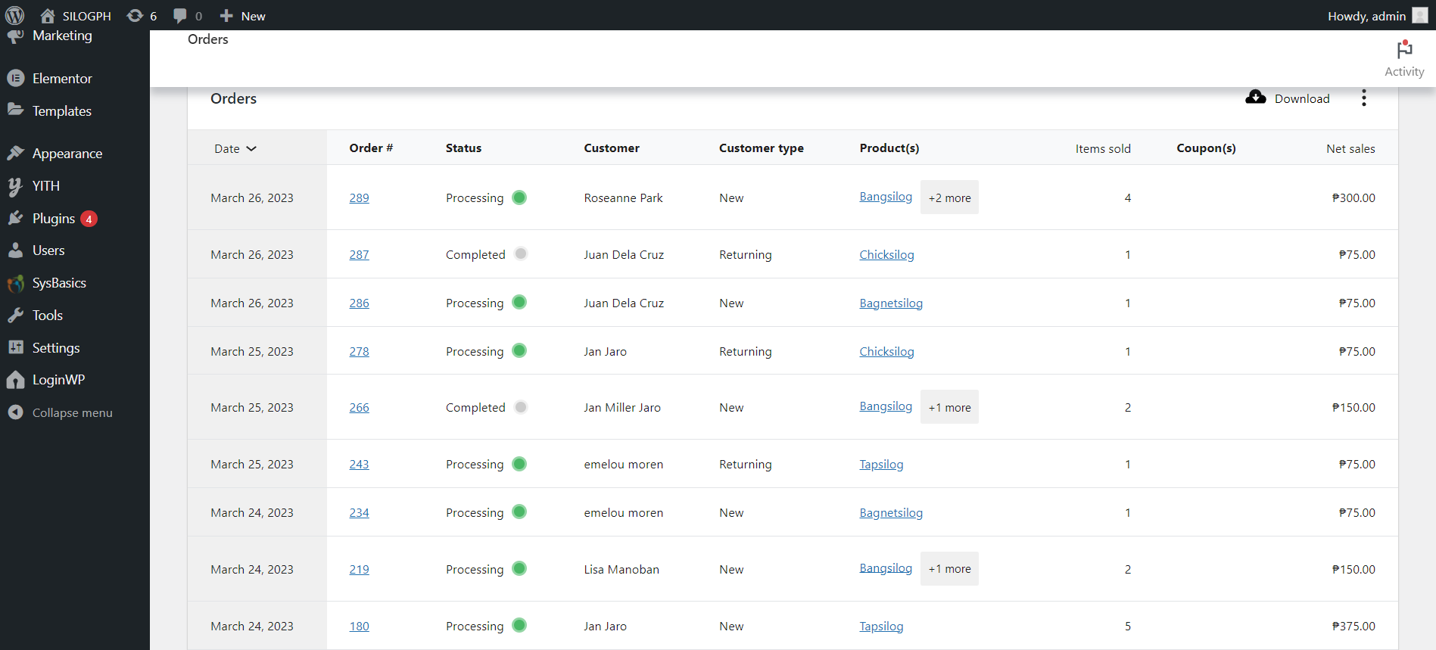

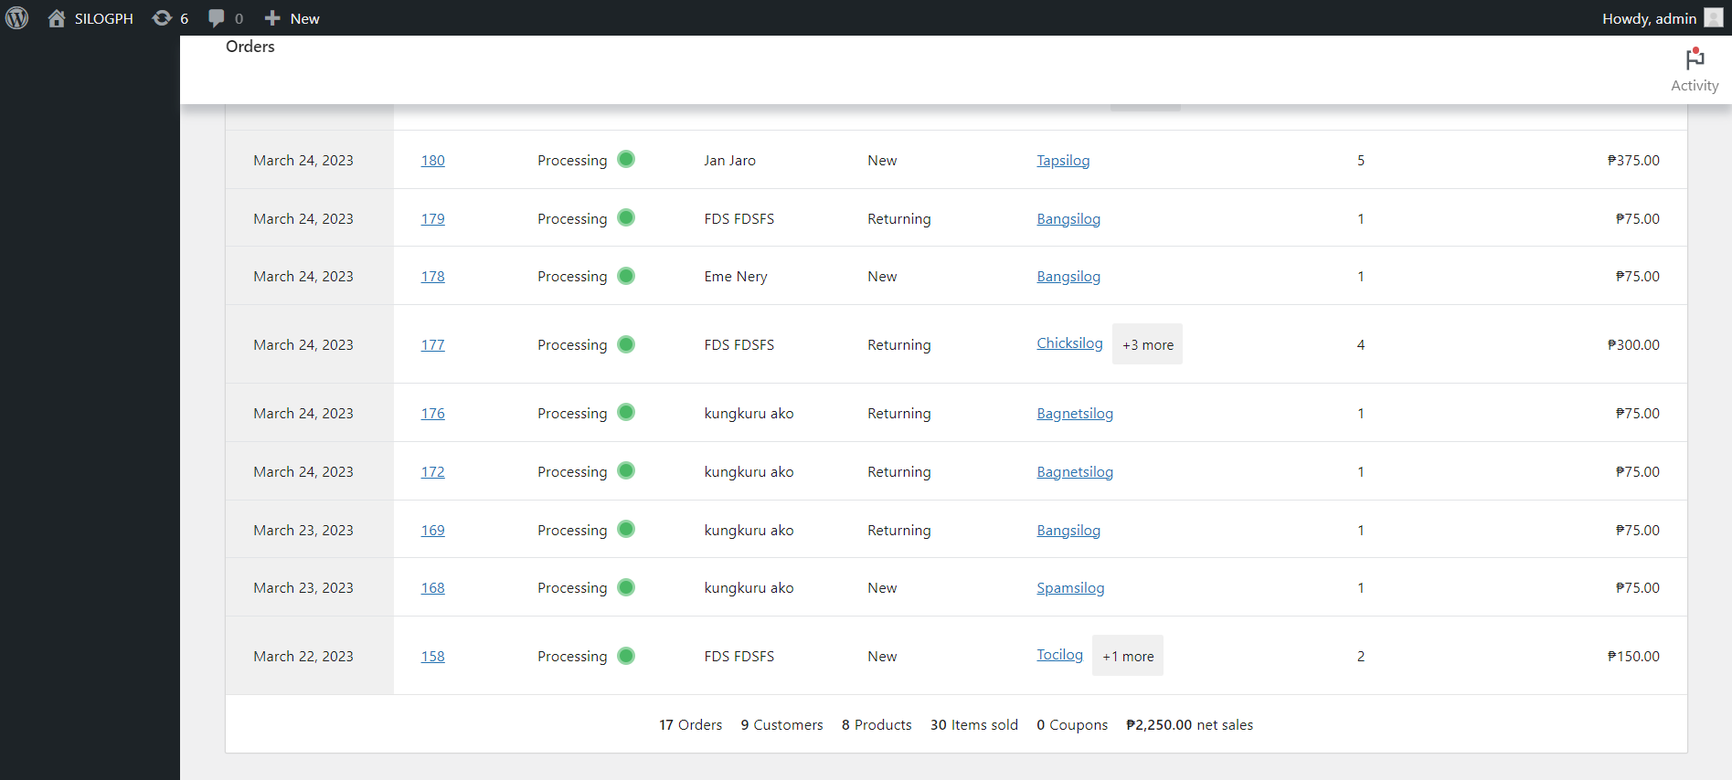

| **Field Name** | **Field Type** | **Data Type** | **Validations** | **Field Response/ Behavior** | **Mandatory** |
| --- | --- | --- | --- | --- | --- |
| Date | Table Field | Read only | ●   Cannot be edited | ● Displays the date when there are orders made. | No |
| Order # | Table Field | Read only | ●   Cannot be edited | ● Displays the order number. | No |
| Status | Table Field | Read only | ●   Cannot be edited | ●   Displays status of the order whether it is being processed, on hold, completed, cancelled, refunded, and failed. | No |
| Customer | Table Field | Read only | ●   Cannot be edited | ● Displays the names of the customers. | No |
| Customer Type | Table Field | Read only | ●   Cannot be edited | ● Displays whether the customer is a new or returning customer. | No |
| Product(s) | Table Field | Read only | ●   Cannot be edited | ● Displays the products that were purchased. | No |
| Items sold | Table Field | Read only | ●   Cannot be edited | ●Displays the number of items sold. | No |
| Coupon(s) | Table Field | Read only | ●   Cannot be edited | ●Displays the coupon(s) used. | No |
| Net sales | Table Field | Read only | ●   Cannot be edited | ●Displays the total amount of sales minus the coupon value. | No |

**2.2.2.8 View Categories Analytics**

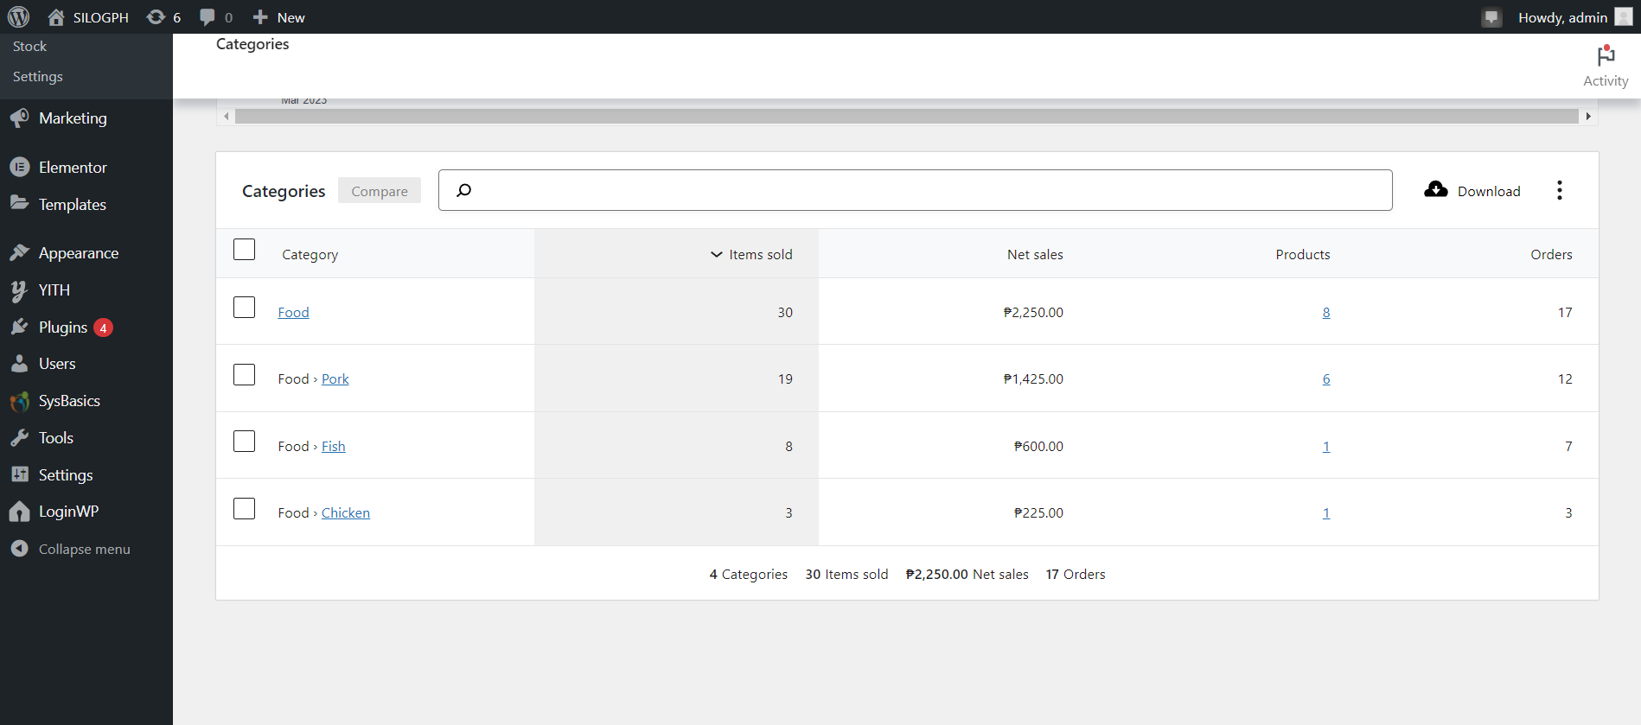

| **Field Name** | **Field Type** | **Data Type** | **Validations** | **Field Response/ Behavior** | **Mandatory** |
| --- | --- | --- | --- | --- | --- |
| Category | Table Field | Read only | ●   Cannot be edited | ● Displays the category of the product. | No |
| Items sold | Table Field | Read only | ●   Cannot be edited | ● Displays the items sold according to the category of the product. | No |
| Net sales | Table Field | Read only | ●   Cannot be edited | ●   Displays the total amount of sales minus returns, and taxes. | No |
| Products | Table Field | Read only | ●   Cannot be edited | ● Displays the number of products sold in each category. | No |
| Orders | Table Field | Read only | ●   Cannot be edited | ●   Displays the number of orders in each category. |  |

**2.2.2.9 View Stock Analytics**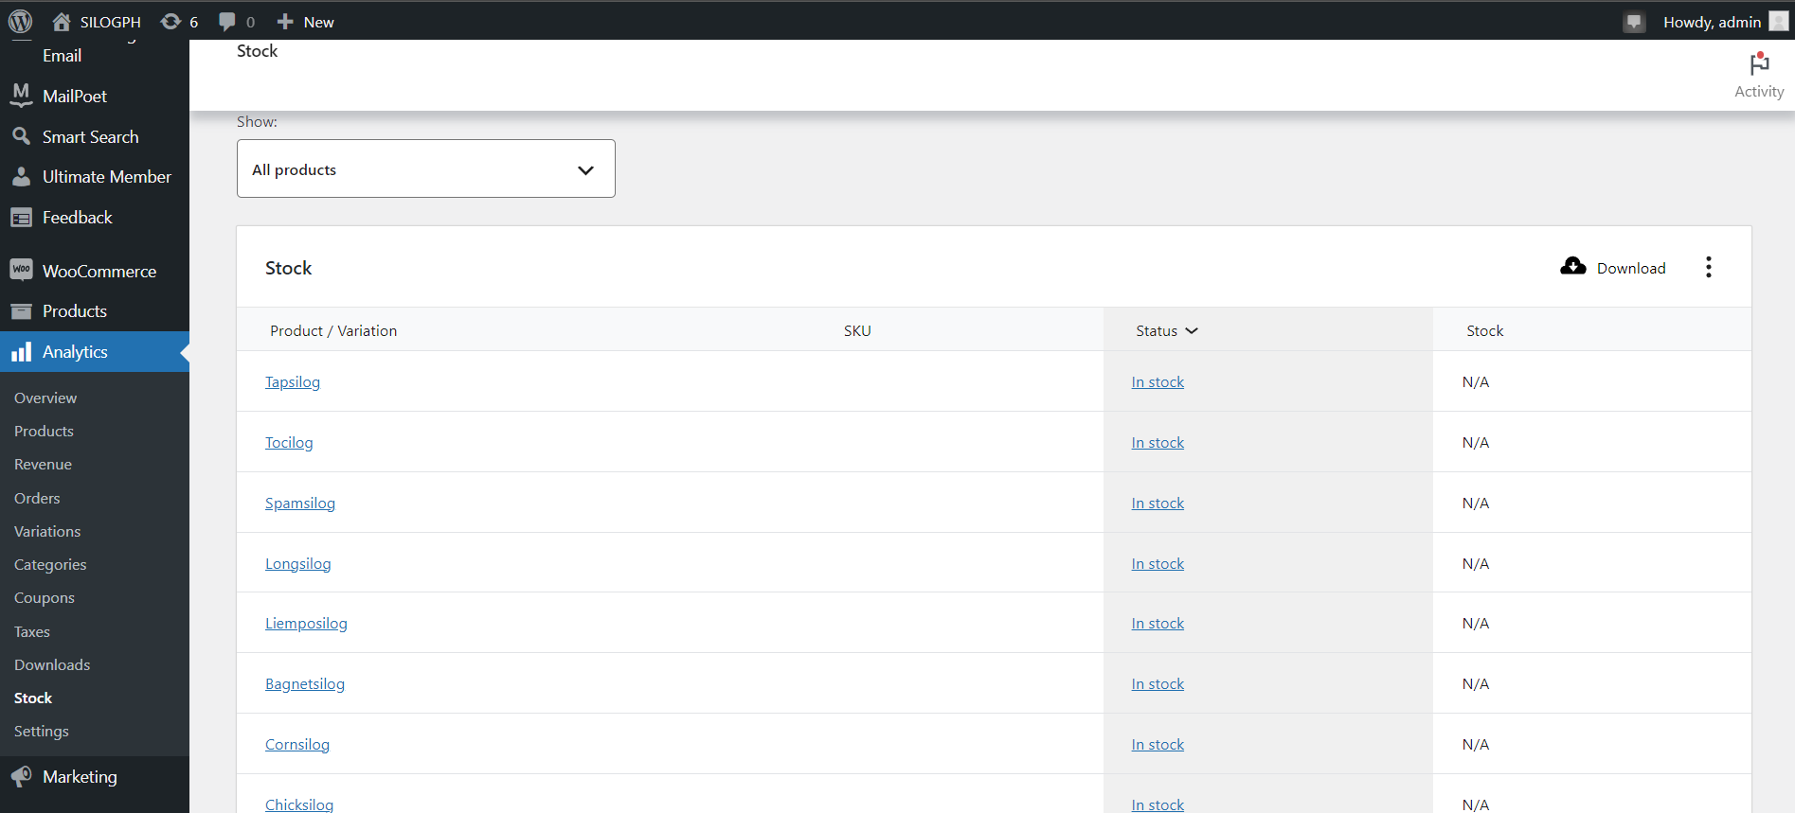

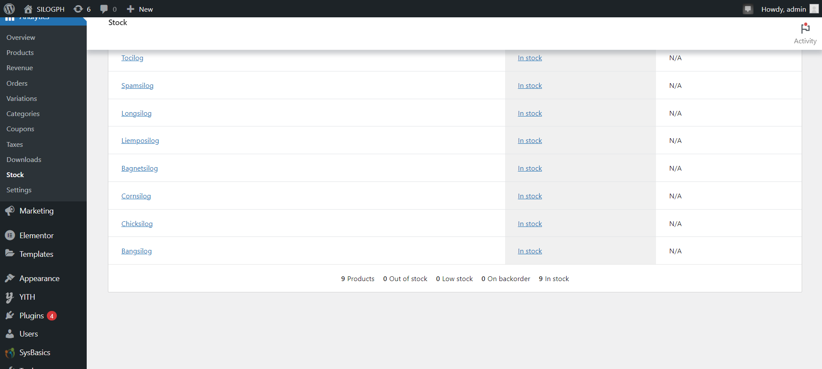

| **Field Name** | **Field Type** | **Data Type** | **Validations** | **Field Response/ Behavior** | **Mandatory** |
| --- | --- | --- | --- | --- | --- |
| Product / Variation | Table Field | Read only | ●   Cannot be edited | ● Displays the product name or variation of the meals. | No |
| Status | Table Field | Read only | ●   Can be edited. | ● Shows whether the product is presently available for purchase by displaying "In stock", “Out of order” or “On backorder”. | No |
| Stock | Table Field | Read only | ●   Cannot be edited | ●   Displays “N/A” by default. | No |

**2.2.2.10 Update Stock**

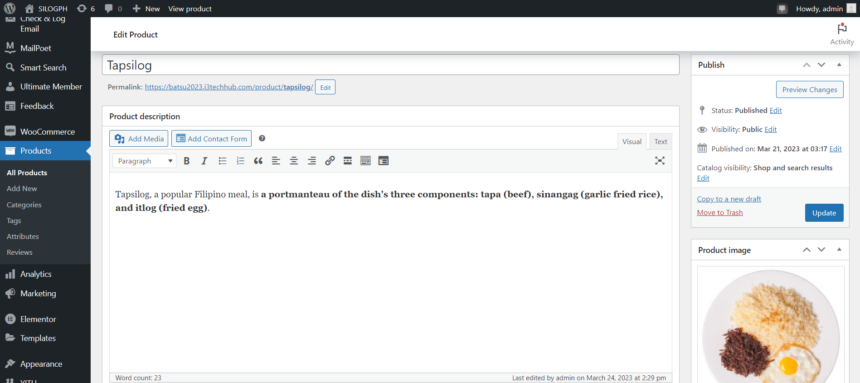

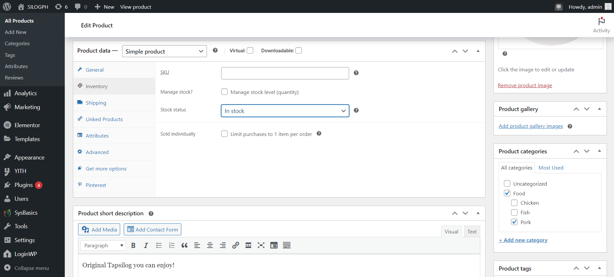

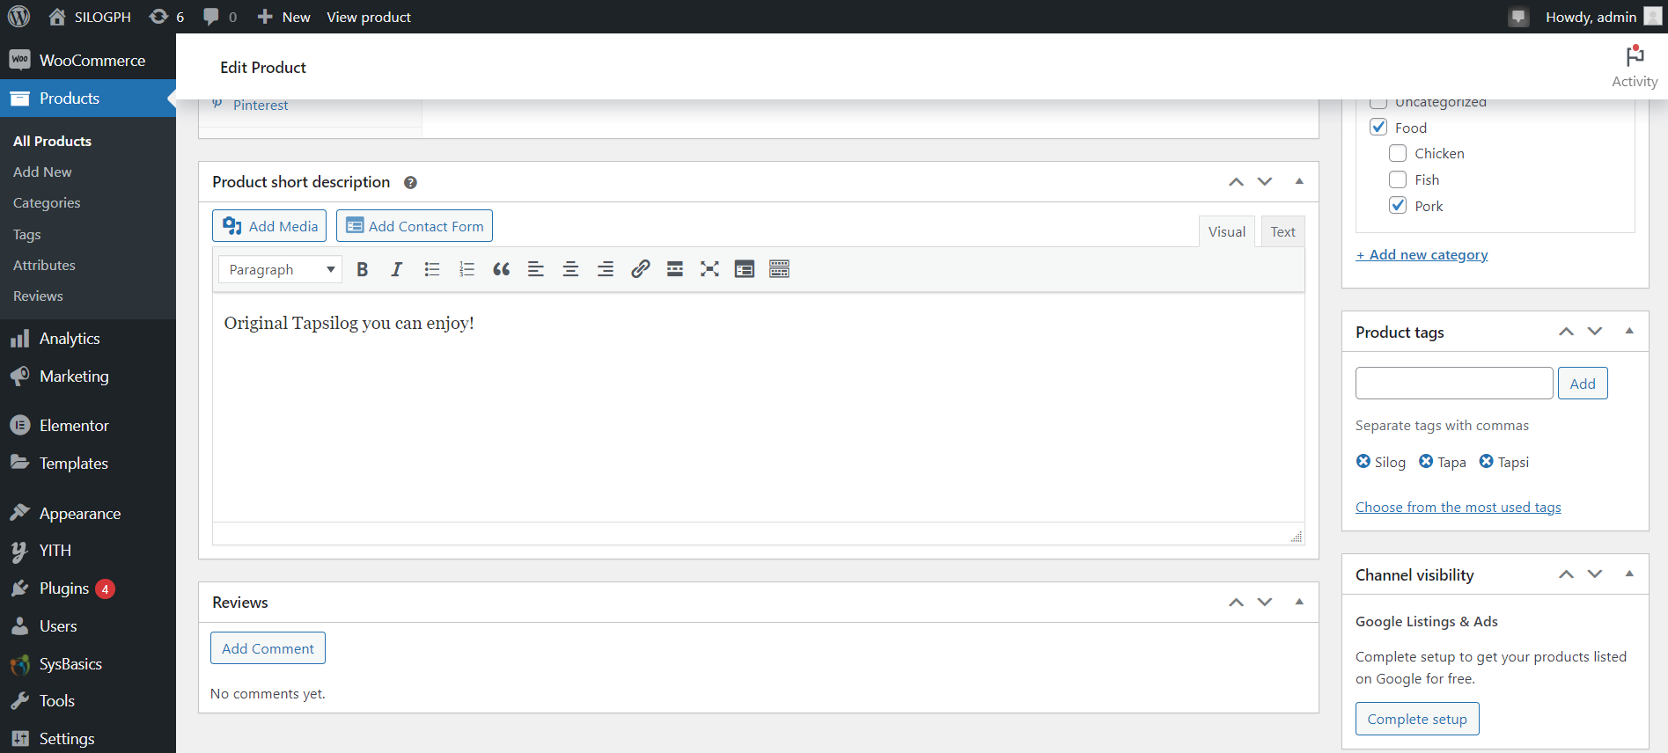

| **Field Name** | **Field Type** | **Data Type** | **Validations** | **Field Response/ Behavior** | **Mandatory** |
| --- | --- | --- | --- | --- | --- |
| Product name | Table Field | String | ●   Can be edited | ● Displays the original product name input.  ● Change the name of the product. | Yes |
| Product description | Table Field | String | ●   Can be edited | ● Displays the original description of the product.  ● Change the description of the product. | Yes |
| Product data | Table Field | String | ●   Can be edited | ● By default, the <blank> option is displayed, and the administrator has the option to select the product type from the dropdown list, as well as choose whether it is a virtual or downloadable product.  ● The regular and sale prices are visible, and the administrator can change the price of the product. | Yes |
| SKU | Table Field | String | ●   Can be edited | ●Displays <empty> by default. | Yes |
| Stock status | Dropdown list | String | ●   Can be edited | ●      Displays “In stock” by default.  ●Displays dropdown list to select values : In stock, out of order, and on backorder. | Yes |
| Product short description | Table Field | String | ●   Can be edited | ● Displays the original product short description of the product.  ● Change the product short description of the product. | Yes |
| Publish | Drop-down list | Text | ● Input should be generated into the database.  ● Input should be displayed on the product page. | ● This section shows the status, visibility, publish immediately, and shop and results options, and only the administrator has the ability to edit and create a draft before publishing it. | Yes |
| Product image | Table Field | Edit | ● Input should be generated into the database.  ● Input should be displayed on the product page. | ● Displays the original image upload by the admin.  ● Change the image of the product. | Yes |
| Product gallery | Table Field | Edit | ● Input should be generated into the database.  ● Input should be displayed on the product page. | ● The administrator can add product gallery images for the product page of newly added products. | Yes |
| Product categories | Drop-down list | Text | ● Input should be generated into the database.  ● Input should be displayed on the product page. | ● This section allows the administrator to create a new product category and also modify existing categories. | Yes |
| Product tags | Table Field | String | ● Input should be generated into the database.  ● Input should be displayed on the product page. | ● Displays the original tags of the product.  ● Add or remove tags and choose from the most commonly used ones. | Yes |
| Channel Visibility | Table Field | String | ● Input should be generated into the database.  ● Input should be displayed on the product page. | ● This section displays the complete setup option, which only the administrator can select to have the products listed on Google for free. | Yes |

**2.2.2.11 Update Delivery Status**

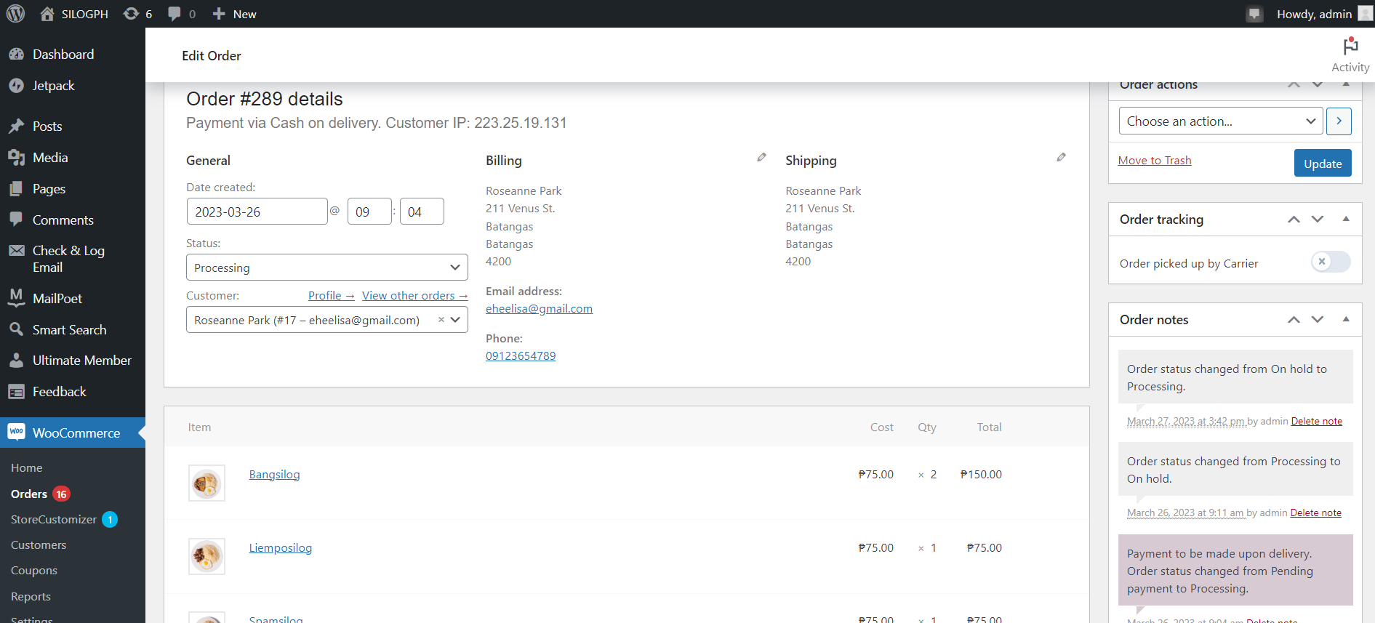

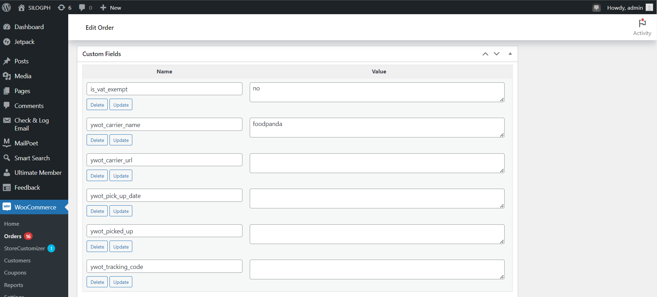

| **Field Name** | **Field Type** | **Data Type** | **Validations** | **Field Response/ Behavior** | **Mandatory** |
| --- | --- | --- | --- | --- | --- |
| Date Created | Date Field | Date | ●   Cannot be edited | ●      Display the time or date when the customer made their order. | Yes |
| Status | Drop-down list | String | ●   Can be edited | ●     Displays the status of the customer’s order, such as whether it is currently being processed, on hold, completed, cancelled, refunded, and failed. | Yes |
| Customer | Text Field | String | ●   Cannot be edited | ●     Displays the name of the customer | Yes |
| Order Actions | Drop-down list | String | ●   Can be edited | ●      Displays “Choose an action” by default.  ●      Dropdown list to select values : Email invoice / order details to customer, Resend new order notification, Regenerate download permissions | Yes |
| Order Notes | Text Field | String | ●   Can be edited | ●   Displays <empty> by default. | Yes |
| Tracking code | Text Field | Integer | ●   Cannot be edited | ●  Displays <empty> by default. | Yes |
| Carrier name | Text Field | String | ●   Can be edited | ●  Displays “foodpanda” as the carrier name. | Yes |
| Carrier website link | Text Field |  | ●   Can be edited | ●  Displays <empty> by default. | Yes |

**2.3   Business Rules**

| **S/N** | **Business Rule** | **Description** | **Message** |
| --- | --- | --- | --- |
| **Create New Account** | | | |
| 1. | User Name is entered by the user when creating a new account. | The user will enter his/her information in the registration page. | N.A |
|  | The First Name is entered by the user when creating a new account. | The user will enter his/her information in the registration page. | N.A |
|  | The last Name is entered by the user when creating a new account. | The user will enter his/her information in the registration page. | N.A |
|  | The Email Address is entered by the user when creating a new account | The user will enter his/her information in the registration page. | N.A |
|  | Password is entered by the user when creating a new account. | The user will enter his/her information in the registration page and character should be contains at least one lowercase letter, one capital letter and one number | N.A |
|  | Confirm Password is entered by the user when creating a new account. | The user will enter his/her information in the registration page and it should be match to the password | Confirm Password |
|  | Phone Number is entered by the user when creating a new account. | The user will enter his/her information in the registration page and it should be match to the password | N.A |
|  | Country / Region | The user will enter his/her information in the registration page and it should be match to the password | N.A |

TEST SUITE REQUIREMENTS

User Module

**Create Billing Address Details**

| S/N | Test Case Description | Test Data | Expected Results | Remarks |
| --- | --- | --- | --- | --- |
|  | Validating User’s First Name | It should be on the record after creating | Storable value | N/A |
|  | Validating User’s Last Name | It should be on the record after creating | Storable value | N/A |
|  | Validating User’s Country/ Region | Country/Region of the User | Dropdown option | N/A |
|  | Validating User’s Street Address | Address of the User | Storable value | N/A |
|  | Validating User’s Town / City | City of the User | Storable value | N/A |
|  | Validating User’s State / County | State of the User | Dropdown option | N/A |
|  | Validating User’s Postcode / ZIP | Postcode of the User | Storable value | N/A |
|  | Validating User’s Phone Number | The phone of the User | Storable value | N/A |
|  | Validating User’s Email | It should be on the record after creating | Storable value | N/A |

**Create Shipping Address**

| S/N | Test Case Description | Test Data | Expected Results | Remarks |
| --- | --- | --- | --- | --- |
|  | Validating User’s First Name | It should be on the record after creating | Storable value | N/A |
|  | Validating User’s Last Name | It should be on the record after creating | Storable value | N/A |
|  | Validating User’s Country/ Region | Country/Region of the User | Dropdown option | N/A |
|  | Validating User’s Street Address | Address of the User | Storable value | N/A |
|  | Validating User’s Town / City | City of the User | Storable value | N/A |
|  | Validating User’s State / County | State of the User | Dropdown option | N/A |
|  | Validating User’s Postcode / ZIP | Postcode of the User | Storable value | N/A |

**Edit Account Details**

| S/N | **Test Case Description** | **Test Data** | **Expected Results** | **Remarks** |
| --- | --- | --- | --- | --- |
|  | Verifying the First Name | The first name entered by the user | Visible | N.A |
|  | Verifying the Last Name | Last name entered by the user | Visible | N.A |
|  | Verifying Display Name | Display Name entered by the user | Visible | N.A |
|  | Verifying Email Address | Email Address inputted by the user | Visible | N.A |
|  | Verifying Current Password | Current Password entered by the user | Can be Visible | N.A |
|  | Verifying New Password | New Password entered by the user | Can be Visible | N.A |
|  | Verifying Confirm Password | Confirm Password entered by the user | Can be Visible | N.A |

**Edit Billing Address Details**

| S/N | **Test Case Description** | **Test Data** | **Expected Results** | **Remarks** |
| --- | --- | --- | --- | --- |
|  | Verifying the First Name | The first name entered by the user | Visible | N.A |
|  | Verifying the Last Name | Last name entered by the user | Visible | N.A |
|  | Verifying Country / Region | Dropdown list: All Country/Region | Visible | N.A |
|  | Verifying Street Address | Street Address inputted by the user | Visible | N.A |
|  | Verifying Town / City | Town / City inputted by the user | Visible | N.A |
|  | Verifying State / County | Dropdown list: All State/County | Visible | N.A |
|  | Verifying Postcode/ Zip Code | Zip Code entered by the user | Visible | N.A |
|  | Verifying Phone No. | Phone number inputted by the user | Visible | N.A |
|  | Verifying Email Address | Email Address inputted by the user | Visible | N.A |

**Edit Shipping Address Details**

| S/N | **Test Case Description** | **Test Data** | **Expected Results** | **Remarks** |
| --- | --- | --- | --- | --- |
|  | Verifying the First Name | User’s first name must be viewable their name to see | Visible | N.A |
|  | Verifying the Last Name | User’s last name is also viewable | Visible | N.A |
|  | Verifying Country / Region | Country/Region of the user can be viewable | Visible | N.A |
|  | Verifying Street Address | Street Address of the user must be viewable | Visible | N.A |
|  | Verifying Town / City | Town / City of the user must be viewable | Visible | N.A |
|  | Verifying State / County | State/County of the user can be viewable | Visible | N.A |
|  | Verifying Postcode/ Zip Code | Postcode/Zip cod of the user must be viewable | Visible | N.A |

**View Home Page**

| S/N | Test Case Description | Test Data | Expected Results | Remarks |
| --- | --- | --- | --- | --- |
|  | Verifying Slider | The Slider should be viewable for user | Visible | N/A |
|  | Verifying Best Seller Product Definition | The Best Seller Product Definition should be viewable for user | Visible | N/A |
|  | Verifying Menu | The Slider should be viewable for user | Visible | N/A |

**View About Us Page**

| S/N | Test Case Description | Test Data | Expected Results | Remarks |
| --- | --- | --- | --- | --- |
|  | Verifying Website Name Definition | The Website Name Definition should be viewable for user | Visible | N/A |
|  | Verifying Website Founder | The Website Founder should be viewable for user | Visible | N/A |

**View Dashboard – My Account Page**

| S/N | Test Case Description | Test Data | Expected Results | Remarks |
| --- | --- | --- | --- | --- |
|  | Verifying Dashboard | The Dashboard should be viewable for user | Visible | N/A |

**View Orders – My Account Page**

| S/N | Test Case Description | Test Data | Expected Results | Remarks |
| --- | --- | --- | --- | --- |
|  | Verifying Order No. | The Order No. should be viewable for user | Visible | N/A |
|  | Verifying Date | The Date should be viewable for user | Visible | N/A |
|  | Verifying Status | The Status should be viewable for user | Visible | N/A |
|  | Verifying Total | The Total should be viewable for user | Visible | N/A |
|  | Verifying Actions | The Actions should be viewable for user | Visible | N/A |
|  | Verifying Product | The Product should be viewable for user | Visible | N/A |
|  | Verifying Price | The Price should be viewable for user | Visible | N/A |
|  | Verifying Subtotal | The Subtotal should be viewable for user | Visible | N/A |

**View Addresses – My Account Page**

| S/N | Test Case Description | Test Data | Expected Results | Remarks |
| --- | --- | --- | --- | --- |
|  | Verifying Billing Address | The Billing Address should be viewable for user | Visible | N/A |
|  | Verifying Shipping Address | The Shipping Address should be viewable for user | Visible | N/A |

**View Account Details – My Account Page**

| S/N | Test Case Description | Test Data | Expected Results | Remarks |
| --- | --- | --- | --- | --- |
|  | Verifying Username | The Username must be viewable | Visible | N/A |
|  | Verifying the First Name | First Name is viewable | Visible | N/A |
|  | Verifying the Last Name | Last Name is viewable | Visible | N/A |
|  | Verifying Email Address | Email address of the user | Visible | N/A |
|  | Verifying Current Password | Current Password of the user | Not Visible | N/A |
|  | Verifying New Password | New Password of the user | Not Visible | N/A |
|  | Verifying Confirm Password | Confirm Password of the user | Not Visible | N/A |

**View Shop Page**

| S/N | Test Case Description | Test Data | Expected Results | Remarks |
| --- | --- | --- | --- | --- |
|  | Verifying of Browse Product | The BrowseProduct should be viewable | Visible | N/A |

**View Cart Page**

| S/N | **Test Case Description** | **Test Data** | **Expected Results** | **Remarks** |
| --- | --- | --- | --- | --- |
|  | Verifying Add/Remove Product | Adding and Removing product by the user must be viewable | Visible | N.A |
|  | Verifying Price | Price of product must be viewable | Visible | N.A |
|  | Verifying Quantity | Quantity of product must be viewable and editable | Visible | N.A |
|  | Verifying Cart Totals | Cart totals must be viewable | Visible | N.A |
|  | Verifying Coupon | Coupon entered by the user must be viewable | Visible | N.A |
|  | Verifying Shipping Address | Shipping Address must be viewable | Visible | N.A |

**View Checkout Page**

| S/N | **Test Case Description** | **Test Data** | **Expected Results** | **Remarks** |
| --- | --- | --- | --- | --- |
|  | Verifying Order Confirmation | Order Confirmation must be viewable | Visible | N.A |
|  | Verifying Order Number | Order Number must be viewable | Visible | N.A |
|  | Verifying Email | Email of the user | Visible | N.A |
|  | Verifying Date | Date of Order must be viewable | Visible | N.A |
|  | Verifying Total | Total Order must be viewable | Visible | N.A |
|  | Verifying Payment Method | Payment Method must be viewable | Visible | N.A |
|  | Verifying Product in Order Details | Product order by the user | Visible | N.A |
|  | Verifying Price in Order Details | Price of order must be viewable | Visible | N.A |
|  | Verifying SubTotal in Order Details | Subtotal of order must be viewable | Visible | N.A |
|  | Verifying Shipping in Order Details | Shipping must be viewable | Visible | N.A |
|  | Verifying Payment Method in Order Details | Payment Method must be viewable | Visible | N.A |
|  | Verifying Total in Order Details | Total of Orders must be viewable | Visible | N.A |
|  | Verifying First Name in Billing Address details | User’s First name must be viewable their name to see | Visible | N.A |
|  | Verifying Last Name in Billing Address details | User’s Last Name is also viewable | Visible | N.A |
|  | Verifying Country / Region in Billing Address details | Country / region must be viewable | Visible | N.A |
|  | Verifying Street Address in Billing Address details | Street Address must be viewable | Visible | N.A |
|  | Verifying Town / City in Billing Address details | Town / City must be viewable | Visible | N.A |
|  | Verifying State/ County in Billing Address details | State/County must be viewable | Visible | N.A |
|  | Verifying Postcode/Zipcode in Billing Address details | Zip Code entered by the user must be viewable | Visible | N.A |
|  | Verifying Phone Number in Billing Address details | Phone number of the user must be viewable | Visible | N.A |
|  | Verifying Email Address in Billing Address details | Email Address of the user must be viewable | Visible | N.A |
|  | Verifying First Name in Billing Address details | User’s First name must be viewable their name to see | Visible | N.A |
|  | Verifying Last Name in Billing Address details | User’s Last Name is also viewable | Visible | N.A |
|  | Verifying Country / Region in Shipping Address details | Country / region must be viewable | Visible | N.A |
|  | Verifying Street Address in Shipping Address details | Street Address must be viewable | Visible | N.A |
|  | Verifying Town / City in Shipping Address details | Town / City must be viewable | Visible | N.A |
|  | Verifying State/ County in Shipping Address details | State/County must be viewable | Visible | N.A |
|  | Verifying Postcode/Zipcode in Shipping Address details | Zip Code entered by the user must be viewable | Visible | N.A |

**Admin Module**

**Edit Website Product Page**

| S/N | Test Case Description | Test Data | Expected Results | Remarks |
| --- | --- | --- | --- | --- |
|  | Verifying Product Name | The Product Name must be viewable | Visible | N/A |
|  | Verifying Product Description | The Product Description should be viewable | Visible | N/A |
|  | Verifying Product Data | The Product Data must be viewable | Visible | N/A |
|  | Verifying SKU | The code of the product must be viewable. | Visible | N/A |
|  | Verifying Stock status | The Stock status of the product must be viewable | Visible | N/A |
|  | Verifying Product Short Description | Product Short Description should be viewable | Visible | N/A |
|  | Verifying of Publish | The Publish should be viewable | Visible | N/A |
|  | Verifying Product image | Product image should be viewable | Visible | N/A |
|  | Verifying Product gallery | Product gallery should be viewable | Visible | N/A |
|  | Verifying Product categories | Product categories must be viewable | Visible | N/A |
|  | Verifying Product tags | Product tags should be viewable | Visible | N/A |
|  | Verifying Channel visibility | Channel visibility should be viewable | Visible | N/A |

**View Website Product Page**

| S/N | Test Case Description | Test Data | Expected Results | Remarks |
| --- | --- | --- | --- | --- |
|  | Verifying of Name | The Name must be viewable | Visible | N/A |
|  | Verifying of Stock | The Stock should be viewable | Visible | N/A |
|  | Verifying of Price | The Price must be viewable | Visible | N/A |
|  | Verifying of Categories | Categories should be viewable | Visible | N/A |
|  | Verifying of Tags | The Tags should be viewable | Visible | N/A |
|  | Verifying of Date | The date must be viewable | Visible | N/A |
|  | Verifying of Stats | The Stats must be viewable | Visible | N/A |

**View Order Page**

| S/N | Test Case Description | Test Data | Expected Results | Remarks |
| --- | --- | --- | --- | --- |
|  | Verifying of Order | The Order must be viewable | Visible | N/A |
|  | Verifying of Date | The date should be viewable | Visible | N/A |
|  | Verifying of Status | The Status must be viewable | Visible | N/A |
|  | Verifying of Billing Details | Billing details should be viewable | Visible | N/A |
|  | Verifying of Shipping Details | Shipping details should be viewable | Visible | N/A |
|  | Verifying of Total Amount | The total amount must be viewable | Visible | N/A |
|  | Verifying Action | Action should be viewable | Visible | N/A |

**View Customer Details**

| S/N | Test Case Description | Test Data | Expected Results | Remarks |
| --- | --- | --- | --- | --- |
|  | Verifying of Name | The Name must be viewable | Visible | N/A |
|  | Verifying Username | The Username should be viewable | Visible | N/A |
|  | Verifying of Last active | Lat active must be viewable | Visible | N/A |
|  | Verifying Date registered | Date registered should be viewable | Visible | N/A |
|  | Verifying Email | Email address should be viewable | Visible | N/A |
|  | Verifying Orders | Orders must be viewable | Visible | N/A |
|  | Verifying Total spend | Total Spend should be viewable | Visible | N/A |
|  | Verifying AOV | AOV should be viewable | Visible | N/A |
|  | Verifying Country / Region | Country / Region should be viewable | Visible | N/A |

**View Product Analytics**

| **S/N** | **Test Case Description** | **Test Data** | **Expected Results** | **Remarks** |
| --- | --- | --- | --- | --- |
|  | **Verifying of Product Title** | **The Product Title must be viewable** | **Visible** | **N/A** |
|  | **Verifying of Items Sold** | **The Items Sold should be viewable** | **Visible** | **N/A** |
|  | **Verifying of Net Sales** | **The Net Sales must be viewable** | **Visible** | **N/A** |
|  | **Verifying of Orders** | **Order should be viewable** | **Visible** | **N/A** |
|  | **Verifying of Category** | **Category should be viewable** | **Visible** | **N/A** |
|  | **Verifying of Variations** | **Variations must be viewable** | **Visible** | **N/A** |
|  | **Verifying of Status** | **Status must be viewable** | **Visible** | **N/A** |
|  | **Verifying of Stock** | **Stock must be viewable** | **Visible** | **N/A** |

**View Revenue Analytics**

| S/N | Test Case Description | Test Data | Expected Results | Remarks |
| --- | --- | --- | --- | --- |
|  | Verifying of Date | The Date must be viewable | Visible | N/A |
|  | Verifying Orders | Orders should be viewable | Visible | N/A |
|  | Verifying of Gross Sales | The Gross Sales must be viewable | Visible | N/A |
|  | Verifying Returns | Returns should be viewable | Visible | N/A |
|  | Verifying of Coupons | Coupons should be viewable | Visible | N/A |
|  | Verifying of Net sales | Net sales must be viewable | Visible | N/A |
|  | Verifying Taxes | Taxes should be viewable | Visible | N/A |
|  | Verifying Shipping | Shipping should be viewable | Visible | N/A |
|  | Verifying Total sales | Total Sales should viewable | Visible | N/A |

**View Order Analytics**

| S/N | Test Case Description | Test Data | Expected Results | Remarks |
| --- | --- | --- | --- | --- |
|  | Verifying of Date | The Date must be viewable | Visible | N/A |
|  | Verifying of Order # | Order # should be viewable | Visible | N/A |
|  | Verifying of Status | The Status must be viewable | Visible | N/A |
|  | Verifying of Customer | Customer should be viewable | Visible | N/A |
|  | Verifying of Customer Type | Customer Type should be viewable | Visible | N/A |
|  | Verifying of Product(s) | The Product(s) must be viewable | Visible | N/A |
|  | Verifying Items sold | Items sold should be viewable | Visible | N/A |
|  | Verifying of Coupon(s) | should be viewable | Visible | N/A |
|  | Verifying Net sales | Net sales should be viewable | Visible | N/A |

**View Categories Analytics**

| S/N | Test Case Description | Test Data | Expected Results | Remarks |
| --- | --- | --- | --- | --- |
|  | Verifying of Category | The Category must be viewable | Visible | N/A |
|  | Verifying Items sold | Items sold should be viewable | Visible | N/A |
|  | Verifying Net sales | The Net sales must be viewable | Visible | N/A |
|  | Verifying of Products | Products should be viewable | Visible | N/A |
|  | Verifying of Orders | Orders should be viewable | Visible | N/A |

**View Stock Analytics**

| S/N | Test Case Description | Test Data | Expected Results | Remarks |
| --- | --- | --- | --- | --- |
|  | Verifying Product / Variation | The Product / Variation must be viewable | Visible | N/A |
|  | Verifying Status | Status should be viewable | Visible | N/A |
|  | Verifying Stock | The Stock must be viewable | Visible | N/A |

**Update Stock**

| S/N | Test Case Description | Test Data | Expected Results | Remarks |
| --- | --- | --- | --- | --- |
|  | Verifying Product Name | The Product Name must be viewable | Visible | N/A |
|  | Verifying Product Description | The Product Description should be viewable | Visible | N/A |
|  | Verifying Product Data | The Product Data must be viewable | Visible | N/A |
|  | Verifying Product Short Description | Product Short Description should be viewable | Visible | N/A |
|  | Verifying of Publish | The Publish should be viewable | Visible | N/A |
|  | Verifying Product image | Product image should be viewable | Visible | N/A |
|  | Verifying Product gallery | Product gallery should be viewable | Visible | N/A |
|  | Verifying Product categories | Product categories must be viewable | Visible | N/A |
|  | Verifying Product tags | Product tags should be viewable | Visible | N/A |
|  | Verifying Channel visibility | Channel visibility should be viewable | Visible | N/A |

**Update Delivery Status**

| S/N | Test Case Description | Test Data | Expected Results | Remarks |
| --- | --- | --- | --- | --- |
|  | Verifying of Date Created | The Date Created must be viewable | Visible | N/A |
|  | Verifying of Status | The Status should be viewable | Visible | N/A |
|  | Verifying of Order Actions | The Order Actions must be viewable | Visible | N/A |
|  | Verifying of Order Notes | Order note should be viewable | Visible | N/A |
|  | Verifying of Tracking Code | The Tracking Code should be viewable | Visible | N/A |
|  | Verifying of Carrier Name | The Carrier Name must be viewable | Visible | N/A |
|  | Verifying of Carrier website link | The Carrier website link must be viewable | Visible | N/A |